1. vagrant init

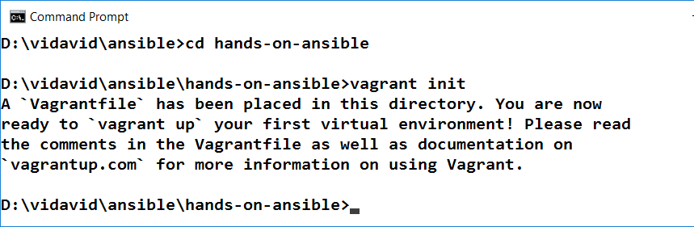

1. Modify the Vagrantfile which has been created as mentioned below:

# -*- mode: ruby -*-

# vi: set ft=ruby :

# All Vagrant configuration is done below. The "2" in Vagrant.configure

# configures the configuration version (we support older styles for

# backwards compatibility). Please don't change it unless you know what

# you're doing.

Vagrant.configure("2") do |config|

config.vm.define "acs" do |acs|

acs.vm.box = "ubuntu/trusty64"

acs.vm.hostname = "acs"

acs.vm.network "private_network", ip : "192.168.33.10"

end

config.vm.define "web" do |web|

web.vm.box = "nrel/CentOS-6.5-x86_64"

web.vm.hostname = "web"

web.vm.network "private_network", ip : "192.168.33.20"

web.vm.network "forwarded_port", guest: 80m host: 8080

end

config.vm.define "db" do |db|

db.vm.box = "nrel/CentOS-6.5-x86_64"

db.vm.hostname = "db"

db.vm.network "private_network", ip : "192.168.33.30"

end

end

1. Enter below command in the command prompt:

**vagrant up**

If you face any challenges in terms of driver related error trouble shoot with below instructions:

**Troubleshooting:**

1. Navigate to "C:\Program Files\Oracle\VirtualBox\drivers\vboxdrv"
2. Right click on "VBoxDrv.inf" file and select Install option
3. Open the Console as a administrator and run the following command sc start vboxdrv

Once the vagrant up is ready you can see below:

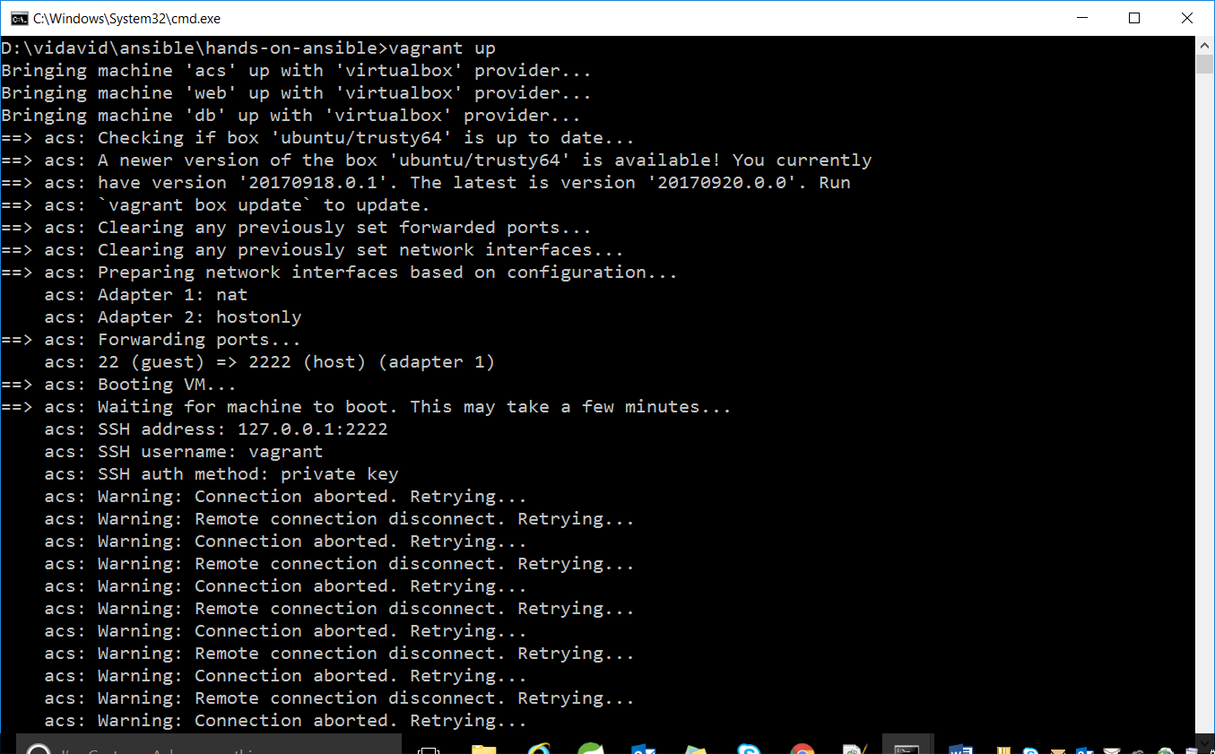

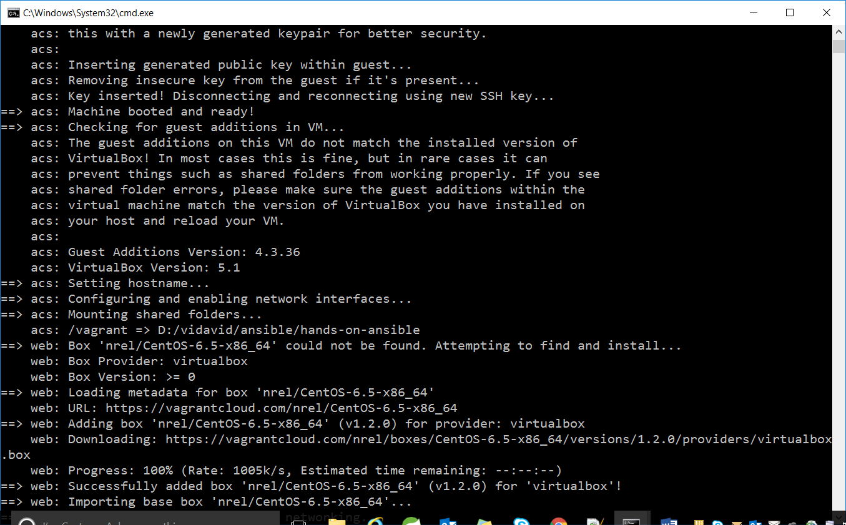

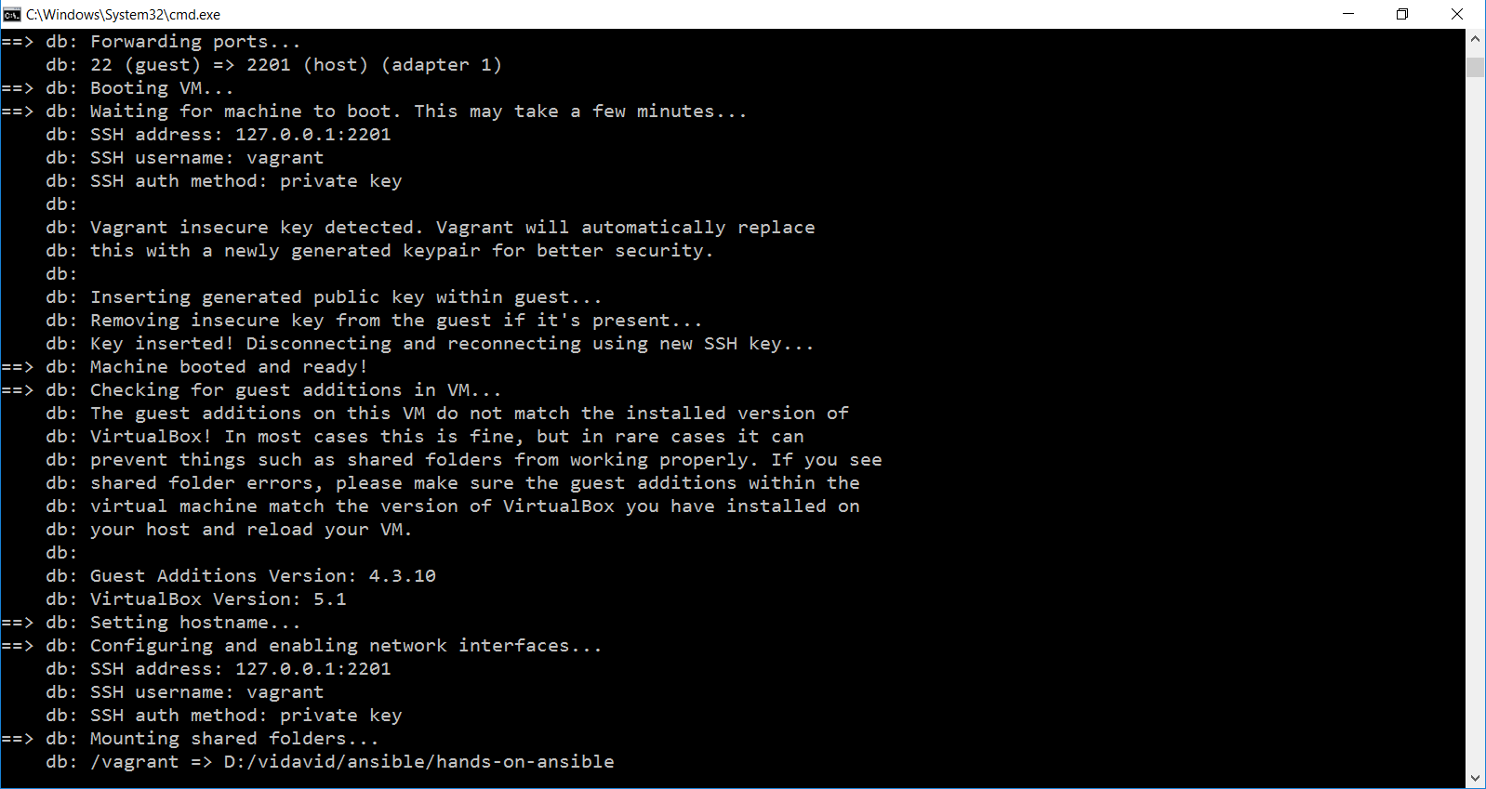

1. To check all running virtual machines use below commands:

**vboxmanage list runningvms**

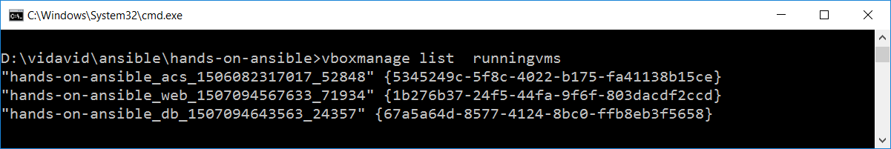

**Installing Ansible:**

1. **vagrant ssh acs**

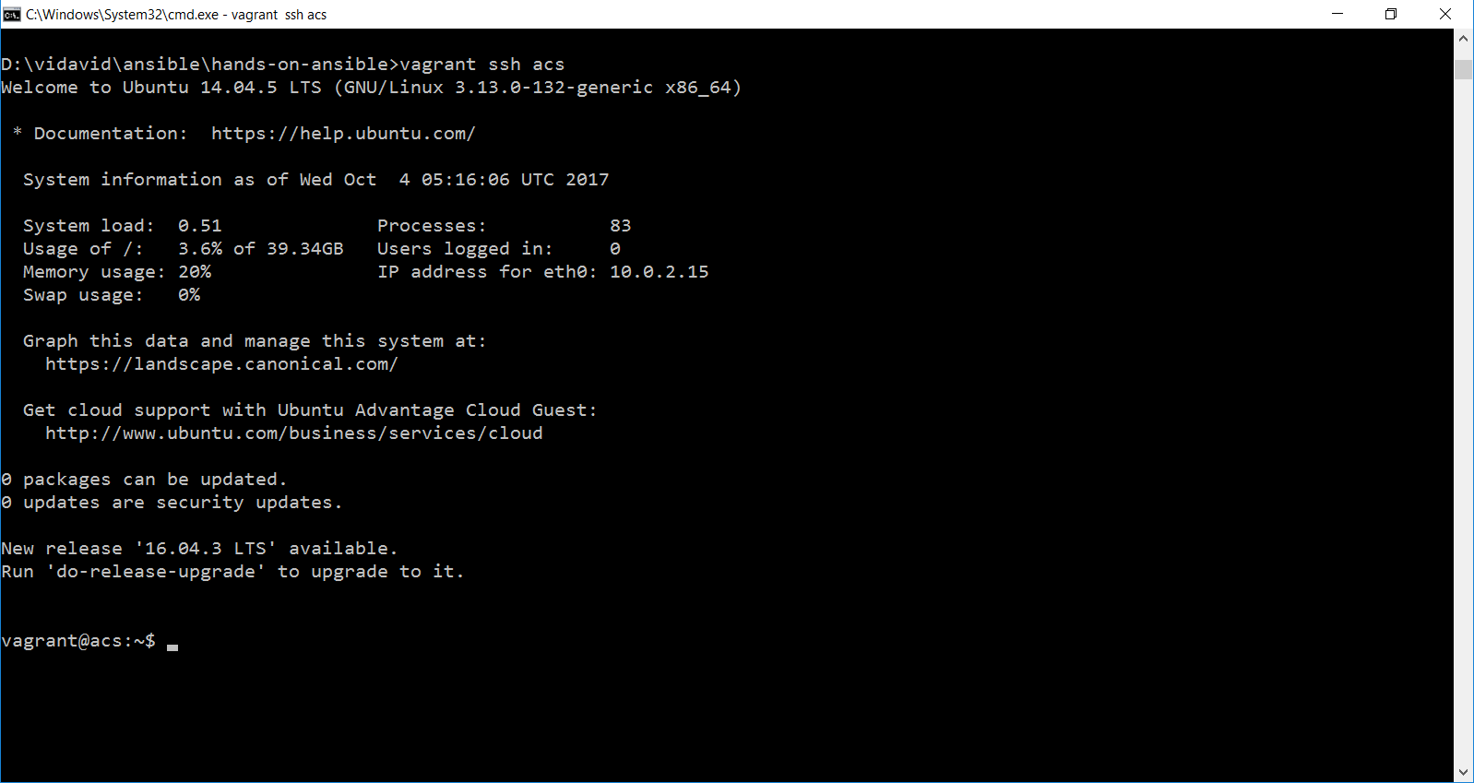

1. use below command to install ansible in acs :

**sudo apt-get install ansible**

**(or)**

**sudo apt-get install ansible --fix-missing**

if you face any authentication issue then use –fix-missing

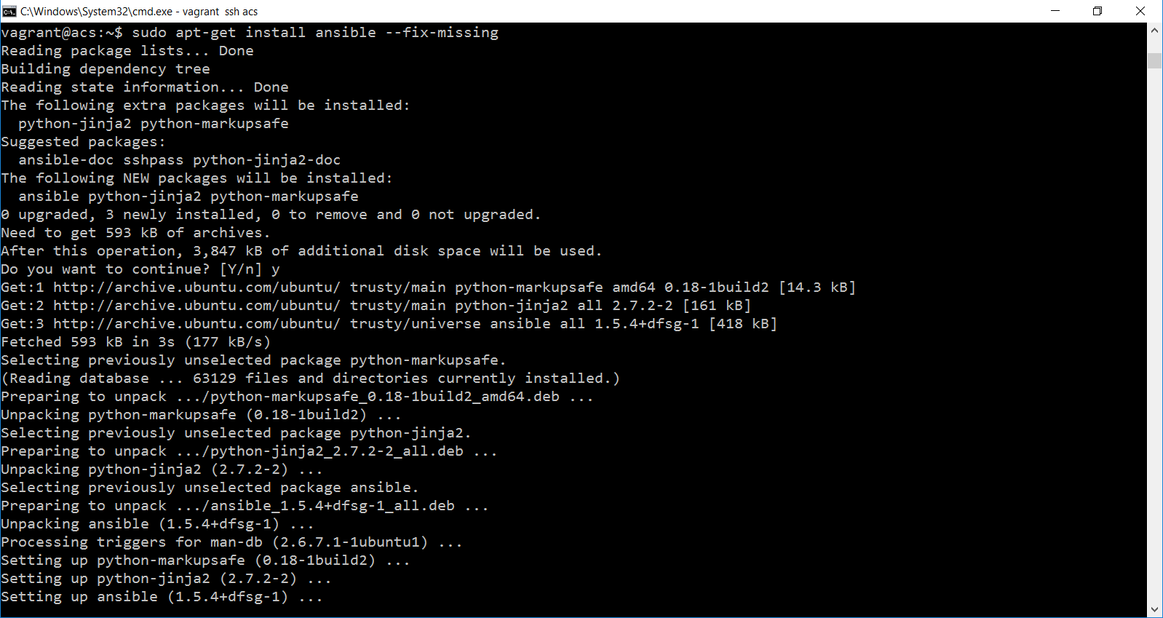

1. To confirm the installation use the below command

**ansible**

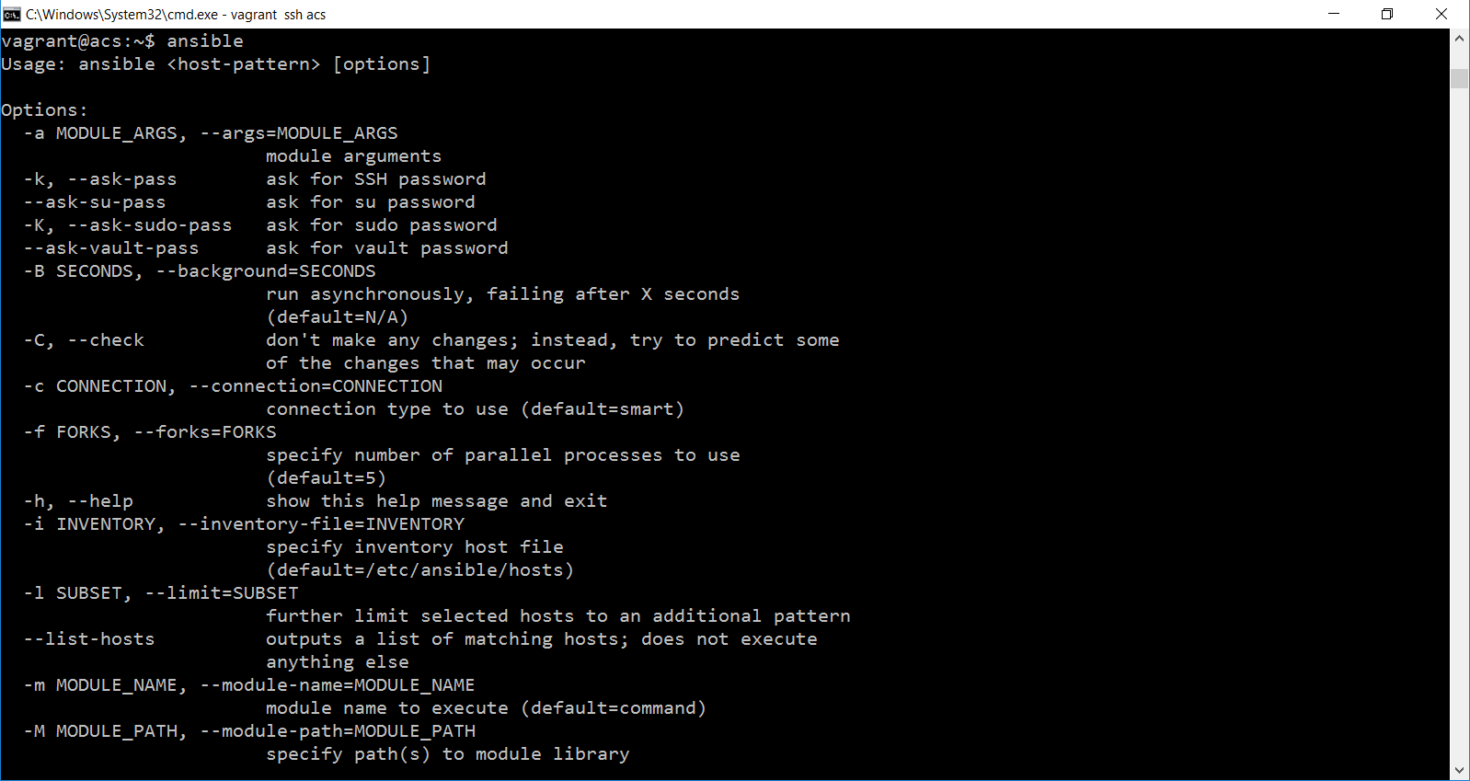

1. Give exit command to install the ansible in linux box

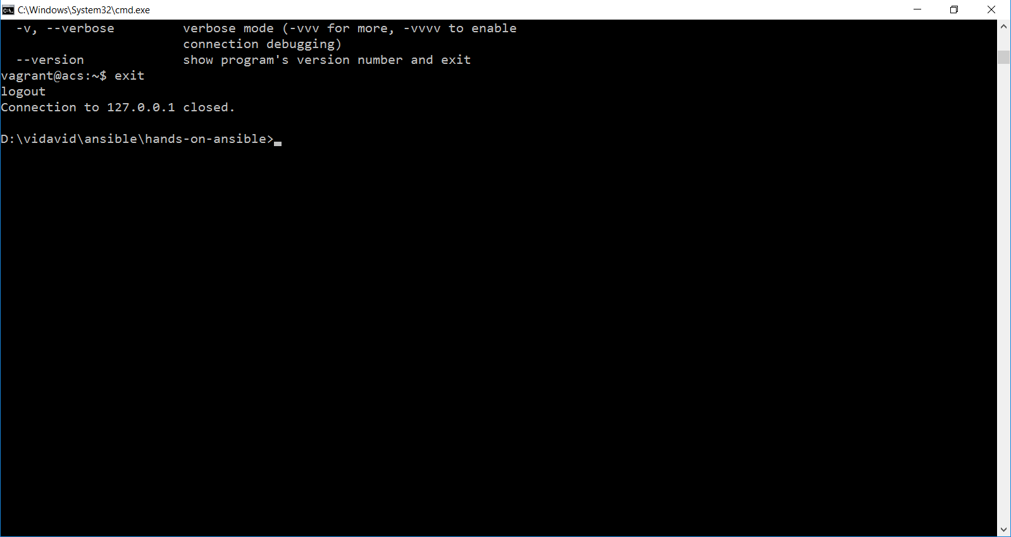

**Installing ansible in web box:**

1. Use below command to enter into web server.

vagrant ssh web

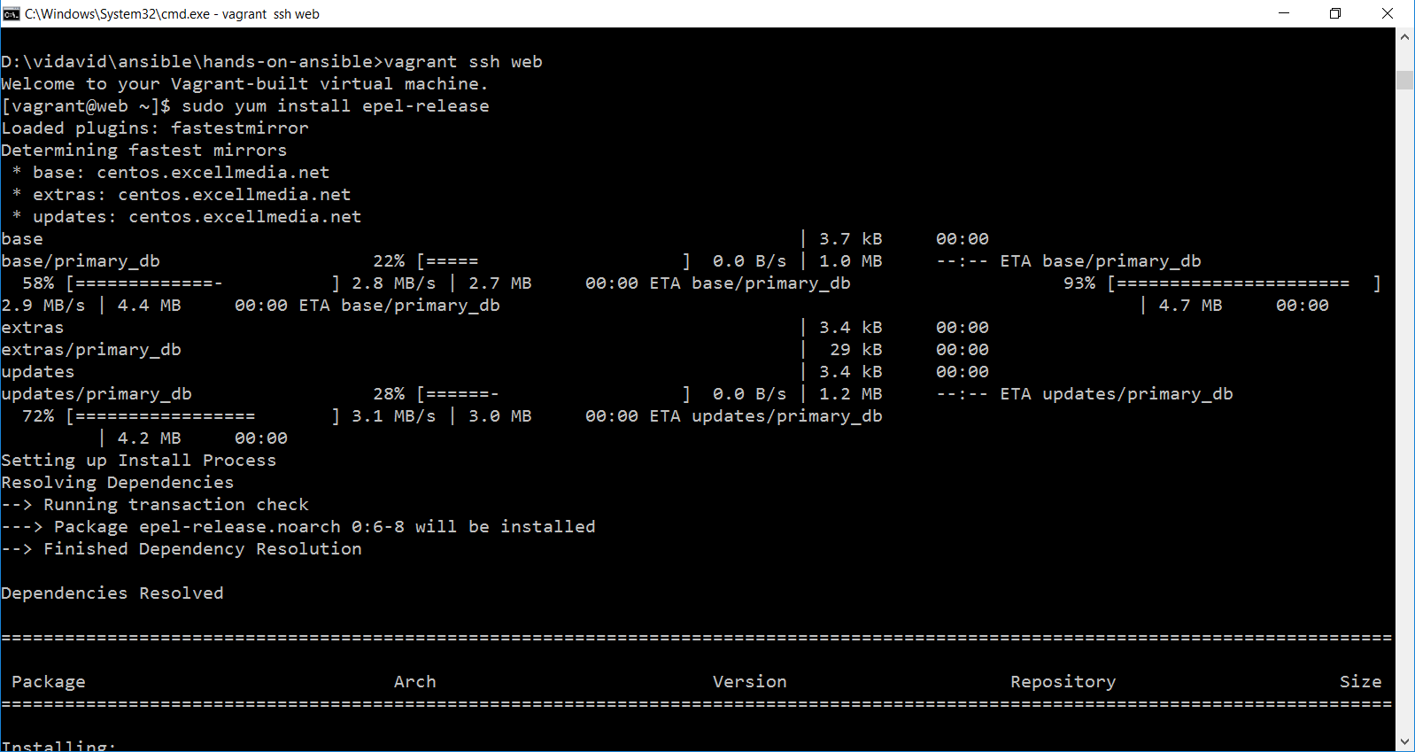

1. To install use below command:

**sudo yum install epel-release**

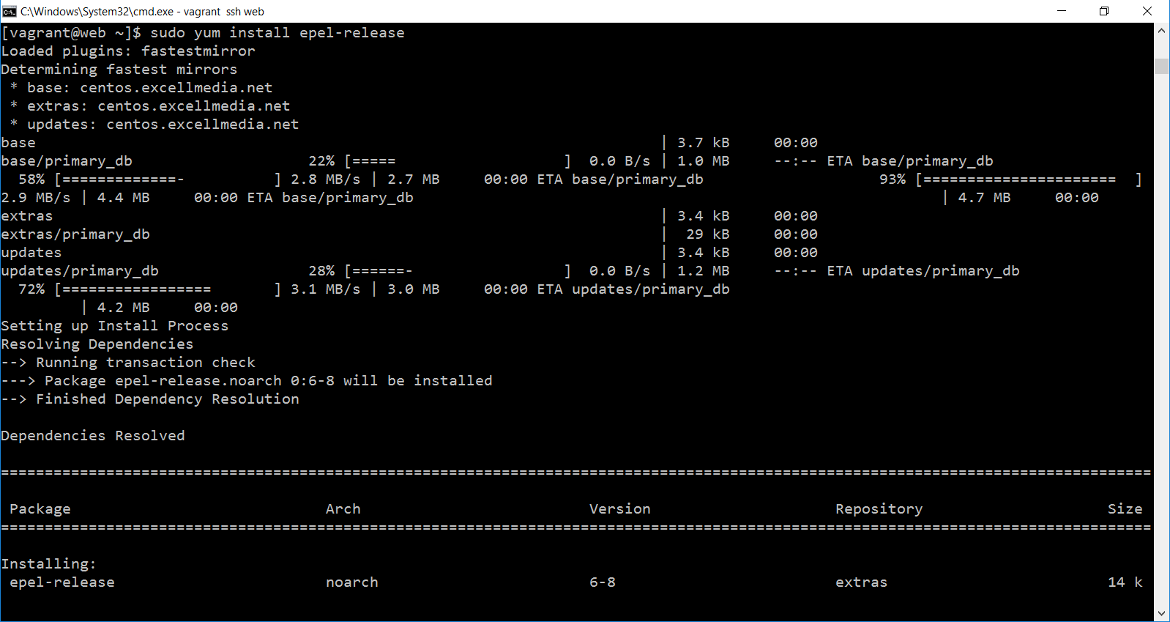

1. To install ansible:

**sudo yum install ansible**

***Troubleshooting:***

If you face any issue related to

***Error: Cannot retrieve metalink for repository: epel. Please verify its path and try again***

First use this command:

**sudo sed -i "s/mirrorlist=https/mirrorlist=http/" /etc/yum.repos.d/epel.repo**

followed by

**sudo yum install ansible**

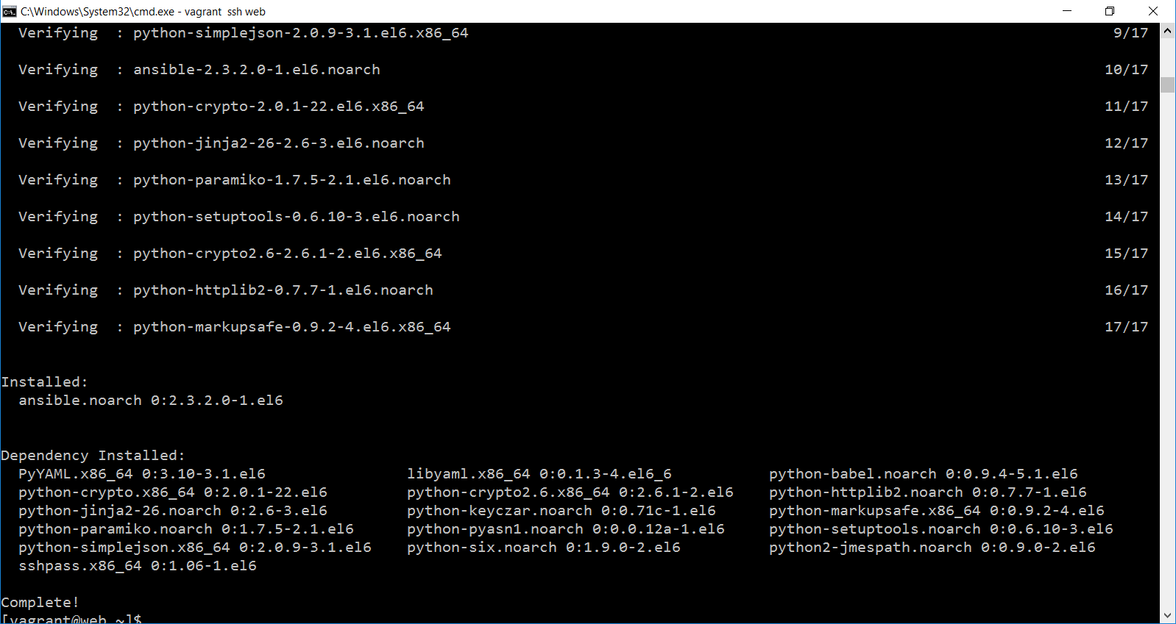

1. To verify ansible properly installed or not in the machine enter below command

**ansible**

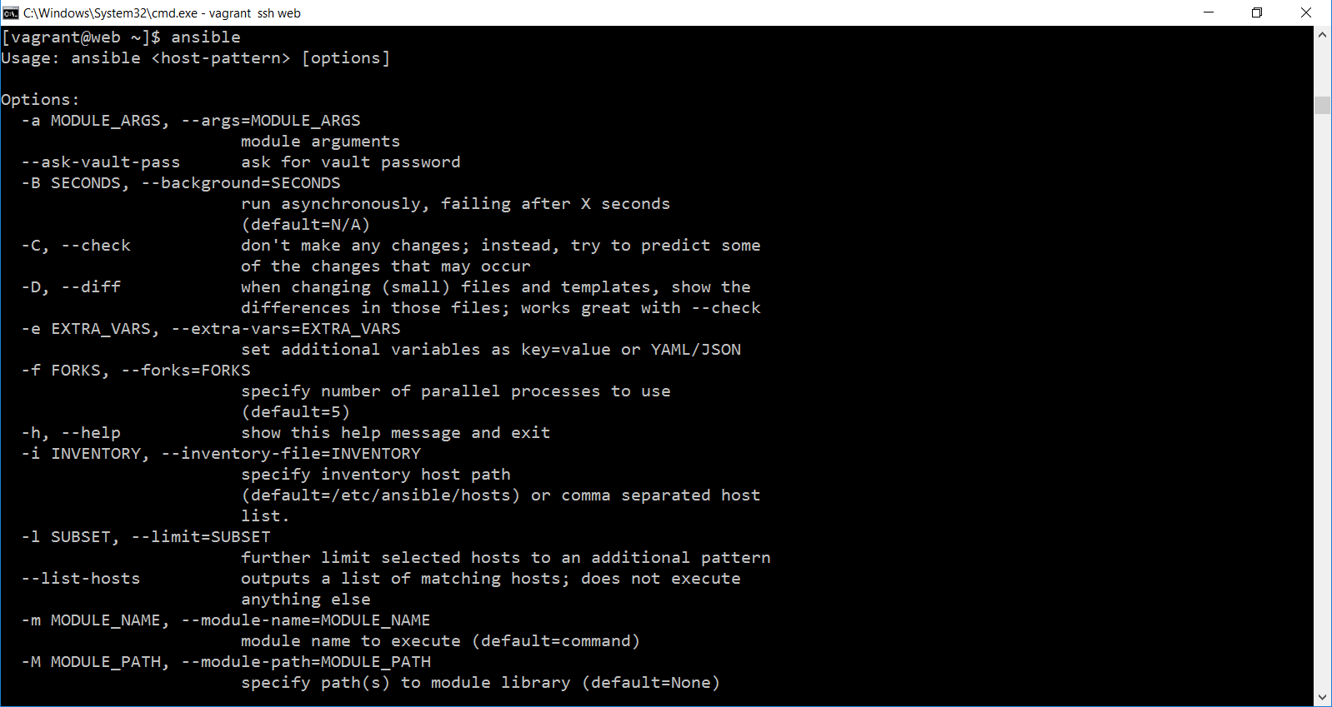

If you get above screen which ensure ansible installed successfully in your machine.

Now we can conclude that ansible has been installed in Ubuntu box and redhat linux box.

**Install ansible in db server**

1. Use below command to enter into db server.

vagrant ssh db

1. Use below command to install repository in your operating system:

**sudo yum install gcc**

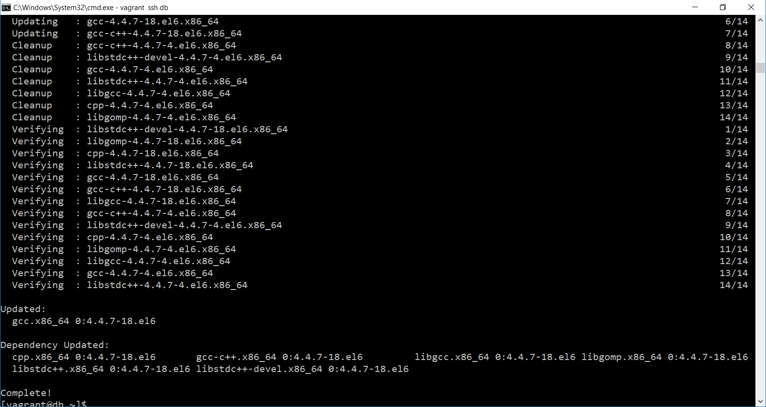

1. Need to install some python dependencies, use below command that will install dependencies:

**sudo yum install python-setuptools**

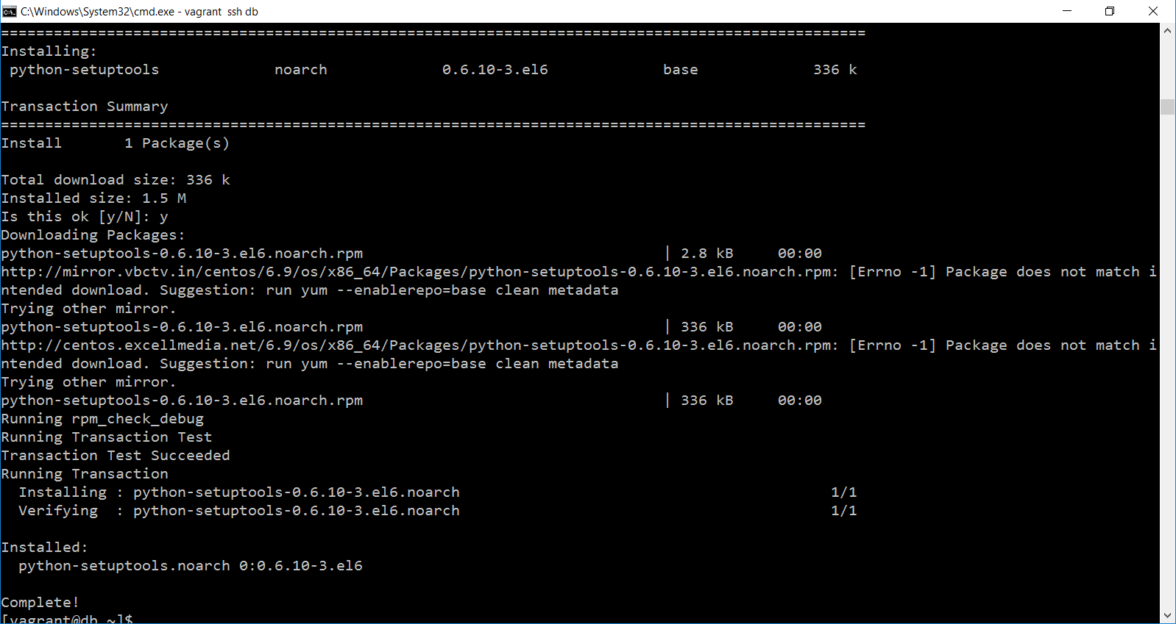

1. Now use below command , that will include few more libraries from python

**sudo easy_install pip**

***Note:***

* ***easy_install command comes from python.***
* ***If it is not installed use the below command and then try.*** ***I guess***[***http://pypi.python.org***](http://pypi.python.org/) ***got serious about requiring https. If you make this little hack then easy_install pip works.***

***sudo sed --in-place 's#http://pypi.python.org#https://pypi.python.org#g' /usr/lib/python2.6/site-packages/setuptools/command/easy_install.py***

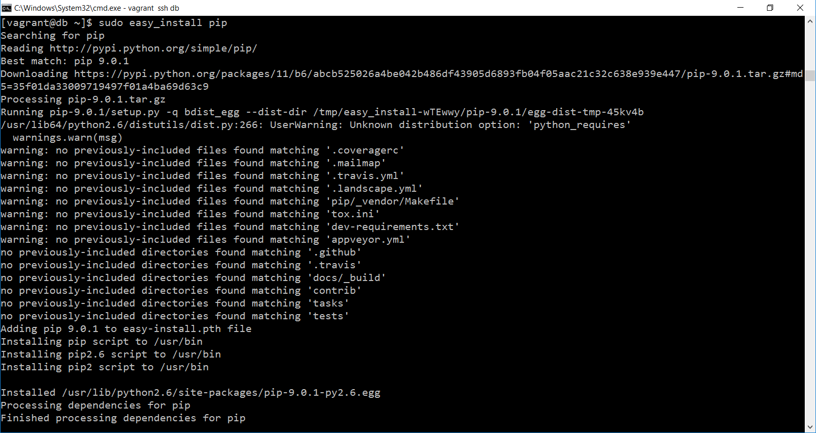

* To install python headers use below command:

**sudo yum install python-devel**

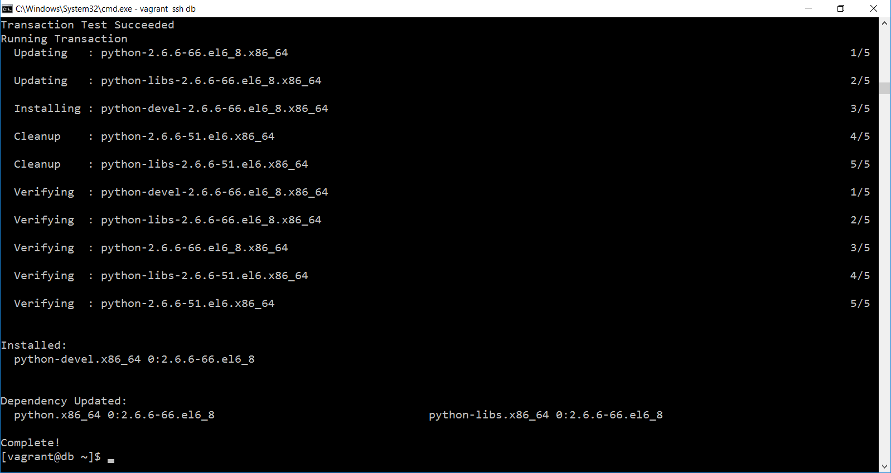

* Now install ansible

sudo pip install ansible

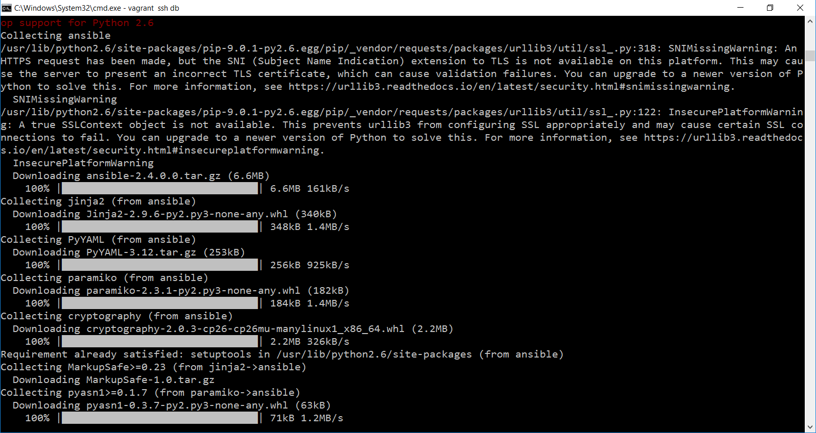

TroubleShoot:

If you face any dependency issue when you install ansible first install below:

sudo yum install libffi-devel

And then install ansible, it will work.

**Ansible – First Lab**

1. Open acs server

vagrant ssh acs

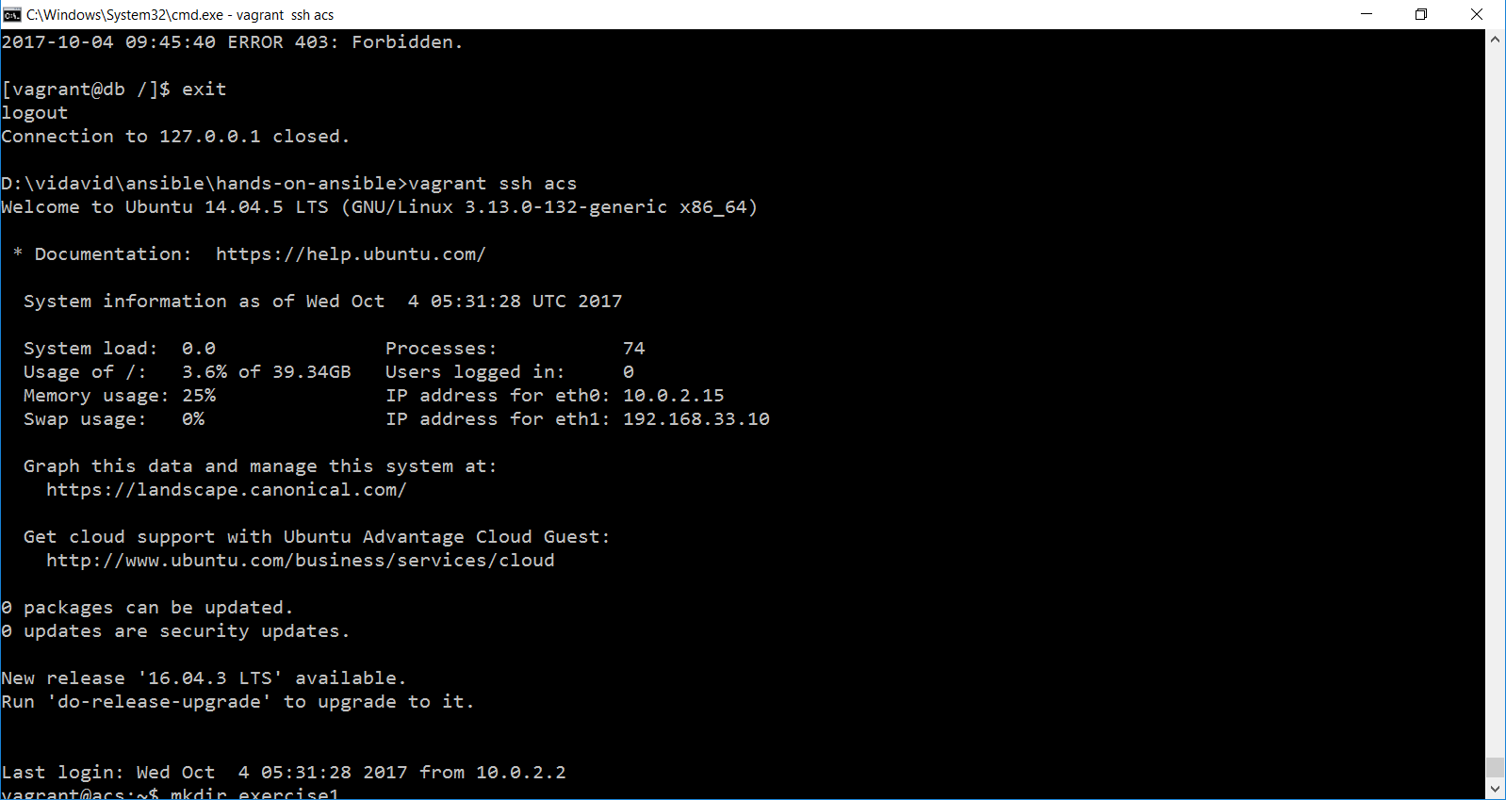

1. Create new directory called exercise1 and open the directory and create inventory file by using following command

* mkdir exercise1
* cd exercise1/
* ls
* vi inventory
  + enter the 192.168.33.20 , 192.168.33.30
  + to save and exit press esc and :wq command in vi editor.

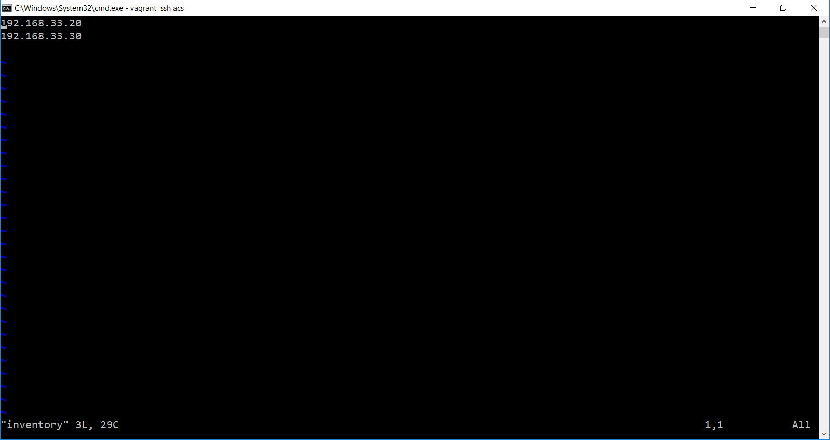

* ansible 192.168.33.20 -i inventory -u vagrant -m ping -k
  + it will ask password enter password as vagrant

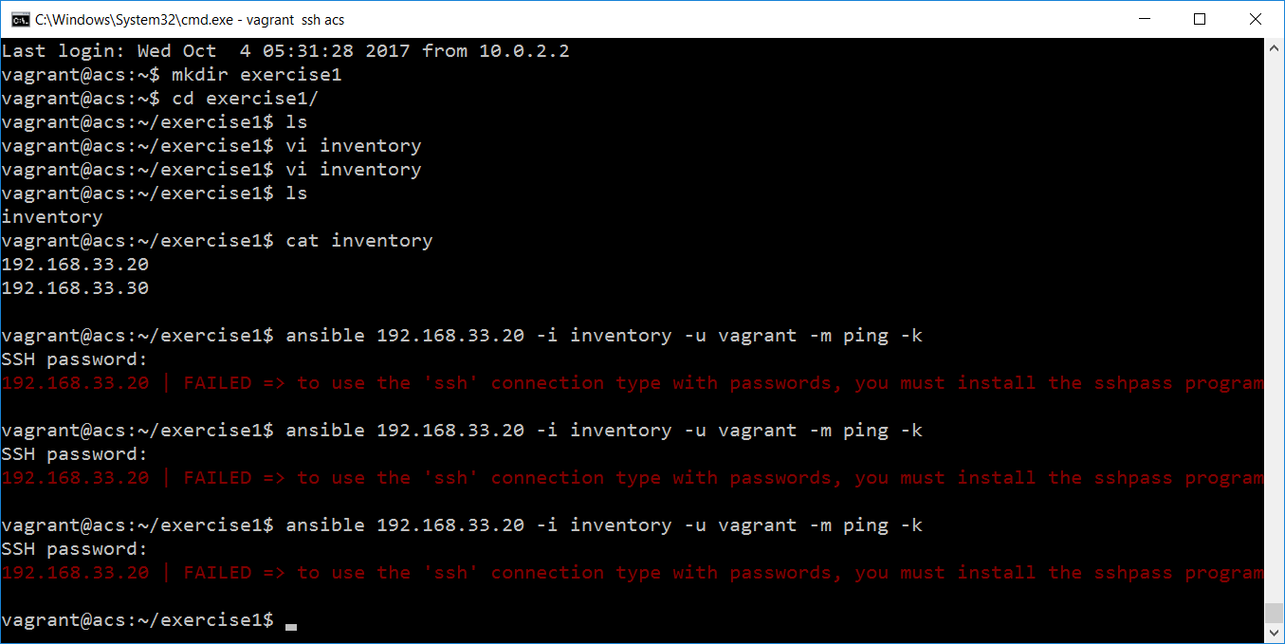

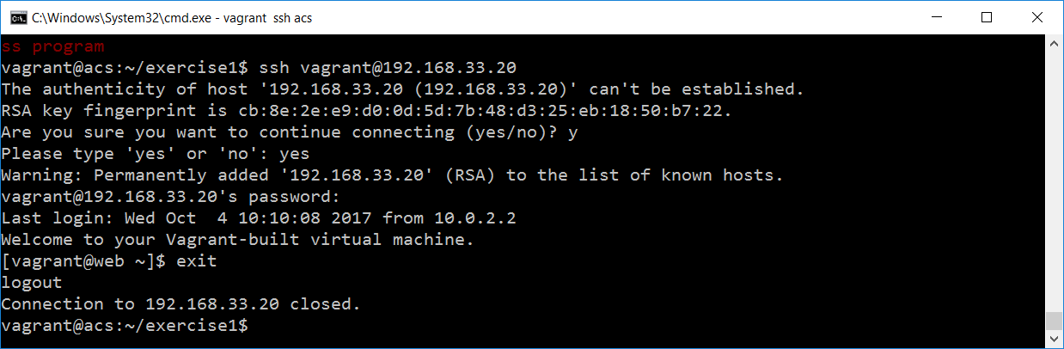

* to authenticate host machine enter below command
  + ls ~/.ssh
  + cat ~/.ssh/known_hosts

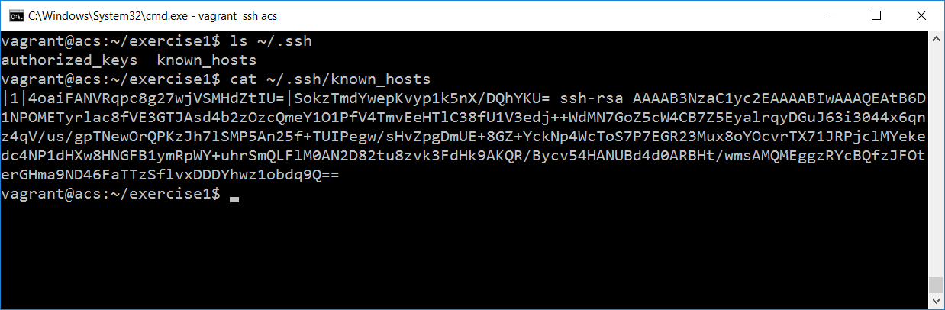

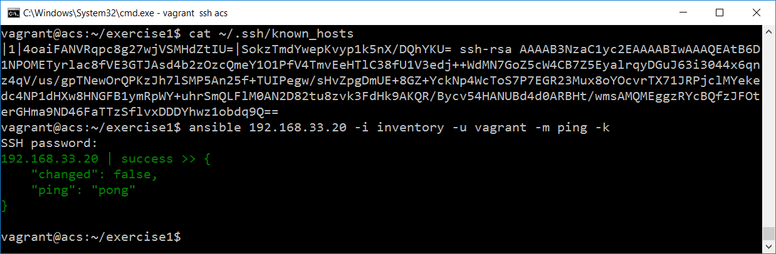

**Trouble shooting:**

**$ ansible all -m ping -k**

SSH password: <type the password here>

hostXXX.ws.nsrc.org | FAILED => to use the 'ssh' connection type with

passwords, you must install the sshpass program

**$ sudo apt-get install sshpass**

...

**$ ansible all -m ping -k**

SSH password: <type the password here>

hostXXX.ws.nsrc.org | success >> {

"changed": false,

"ping": "pong"

}

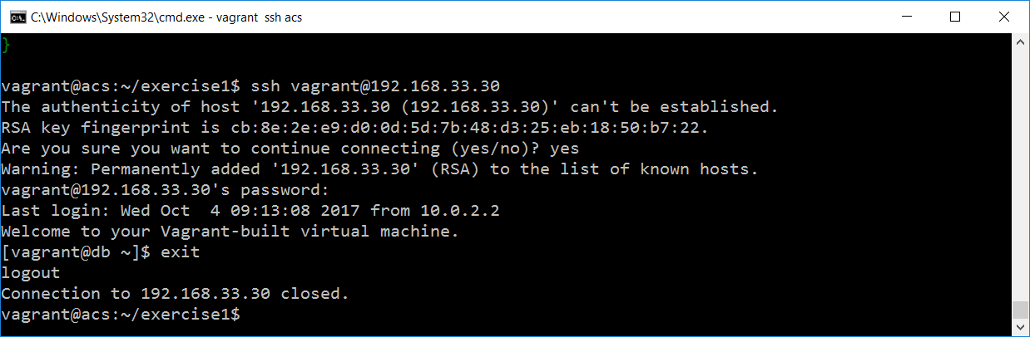

**ansible all -i inventory -u vagrant -m ping -k**

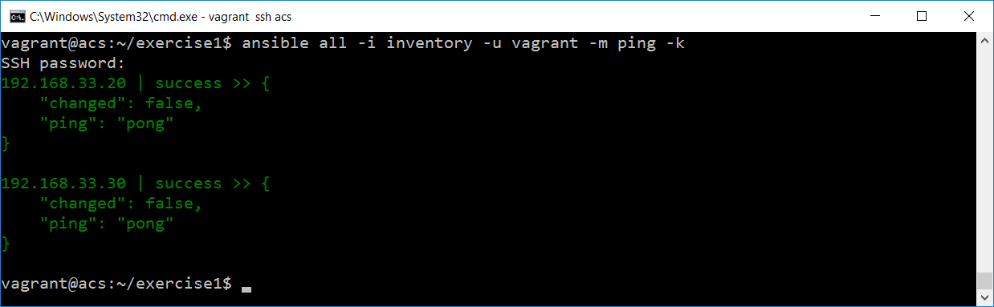

Debugging:

1. To enable debug enter -v , its level 1 debugging. Please see below response

**ansible 192.168.33.20 -i inventory -u vagrant -m ping -k -v**

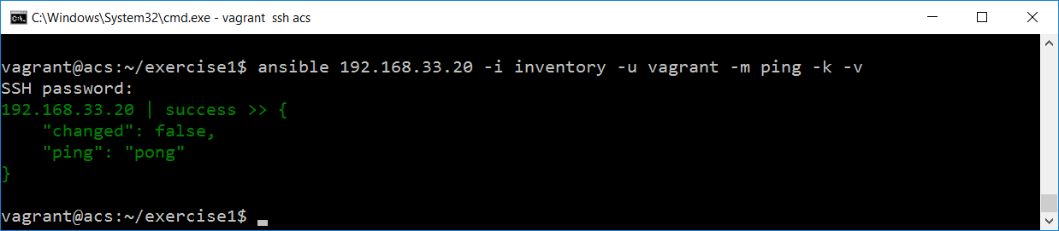

We are not getting the perfect report, now try -vv to enable level 2 debugging.

**ansible 192.168.33.20 -i inventory -u vagrant -m ping -k -vv**

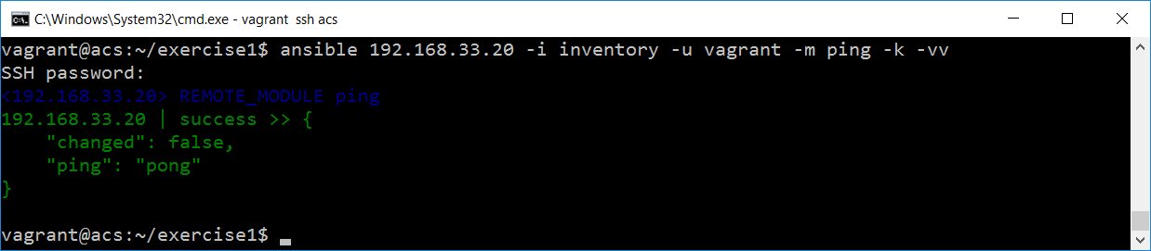

**ansible 192.168.33.20 -i inventory -u vagrant -m ping -k -vvv**

-vvv will enable level 3 debug completely

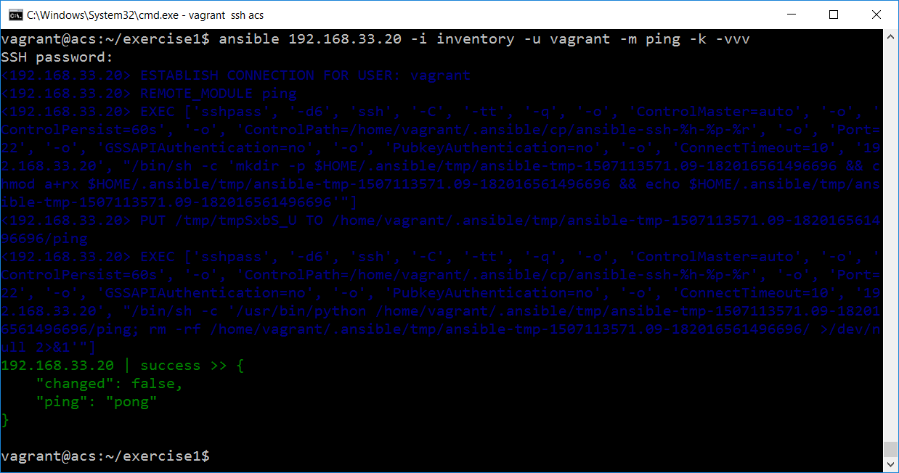

**Ad-hoc commands**

ansible all -i inventory -u vagrant -m command -a "/sbin/reboot"

ansible all -i inventory -u vagrant -m command -a "/sbin/shutdown"

ansible all -i inventory -u vagrant -m command -a "/usr/sbin/ yum update -y"

***Note: you can use the above command without “-m command”. Because that’s default in ansible.***

ansible all -i inventory -u vagrant -a "/sbin/reboot"

We can control all remote machine with this commands

**Inventory Basics:**

1. Run your vagrant

**vagrant up**

1. Check all vbox running or not using below command

**vboxmanage list runningvms**

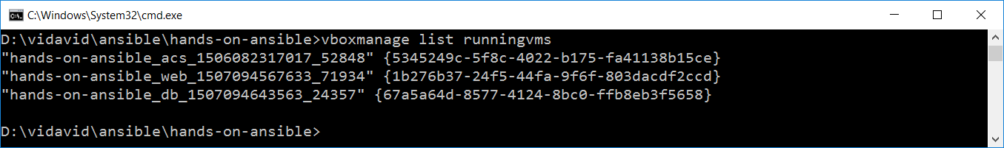

1. Enter into acs server

vagrant ssh acs

1. Create one directory in the name of exercise_4.1
   1. mkdir exercise_4.1
   2. cd exercise_4.1
   3. ls
   4. vim inventory

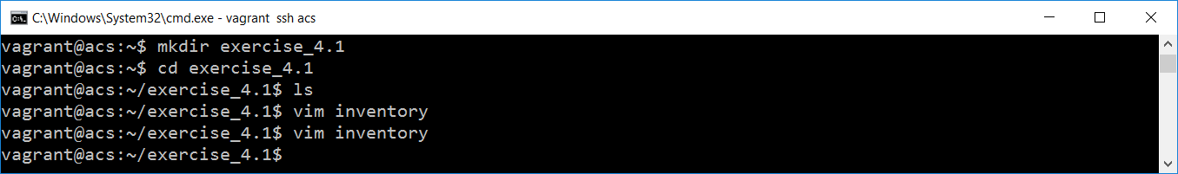

1. in the vim editor enter below details
   1. web1 ansible_ssh_host=192.168.33.20

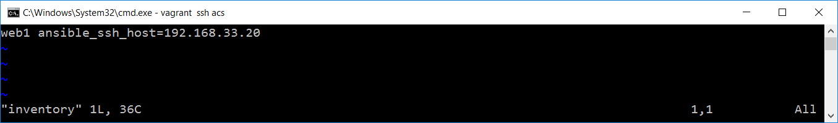

1. Run ansible ad-hoc command

**ansible web1 -i inventory -m ping**

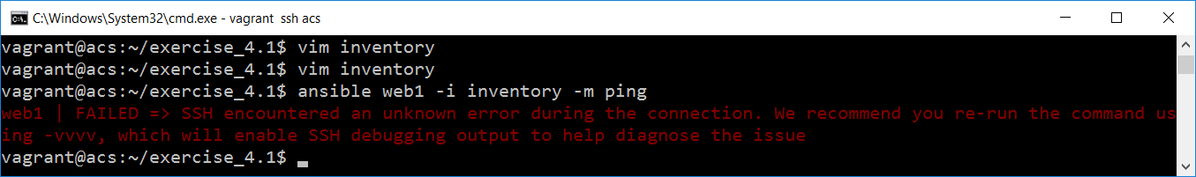

1. Enter username and password in inventory file

**web1 ansible_ssh_host=192.168.33.20 ansible_ssh_user=vagrant ansible_ssh_pass=vagrant**

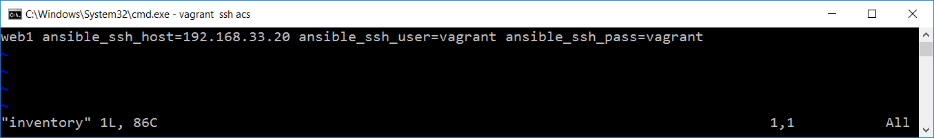

1. Now run ansible ad-hoc command again

**ansible web1 -i inventory -m ping**

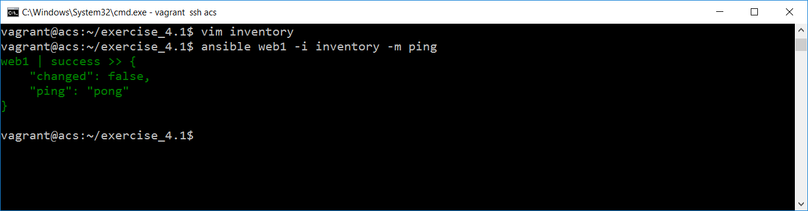

1. Create a group called webservers

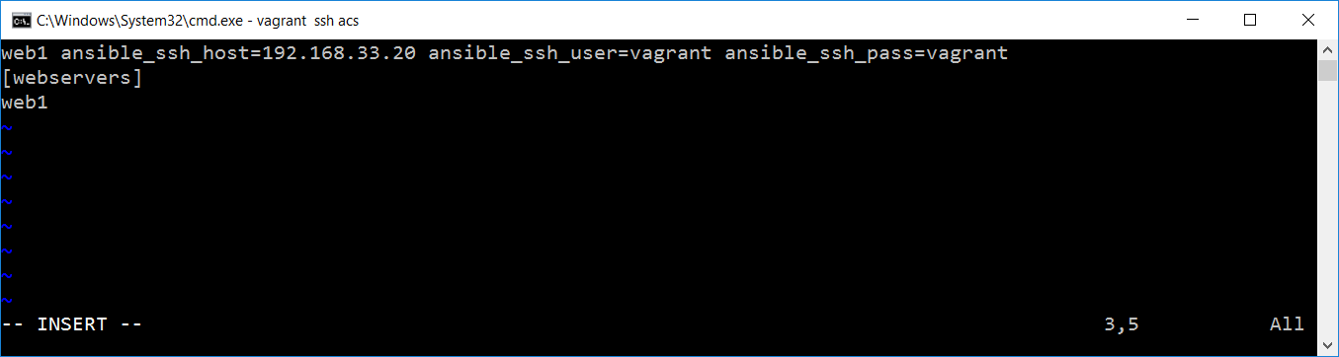

1. Run the adhoc command with group name

**ansible webservers -i inventory -m ping**

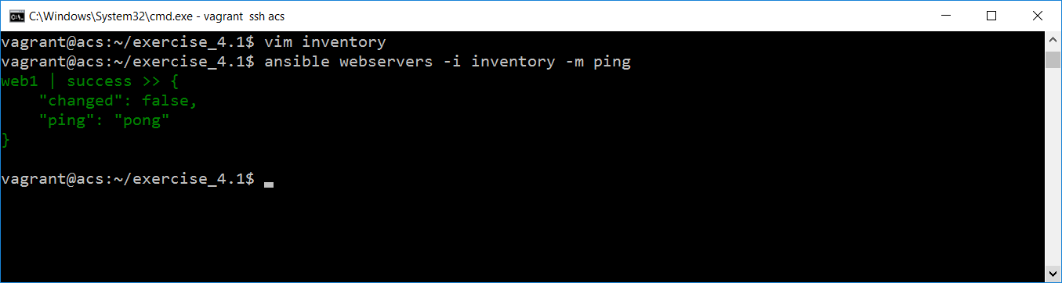

1. Add db1 in the webservers group

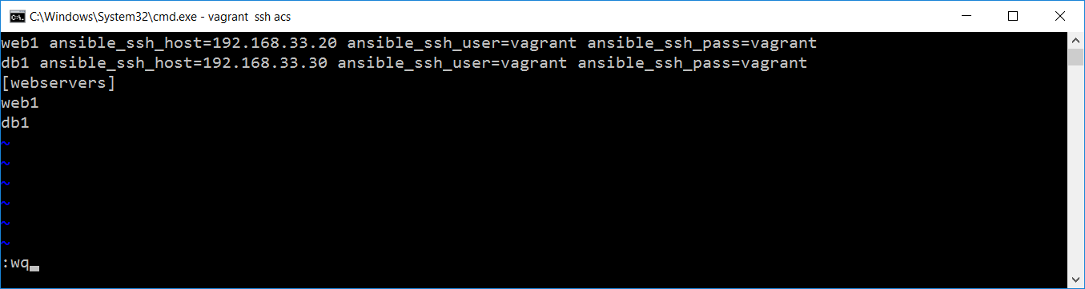

1. Now run the same command, you can see how automation works

**ansible webservers -i inventory -m ping**

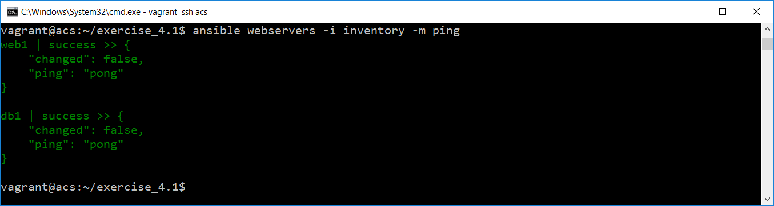

1. Now add one more group called dbservers and datacenter with group details.

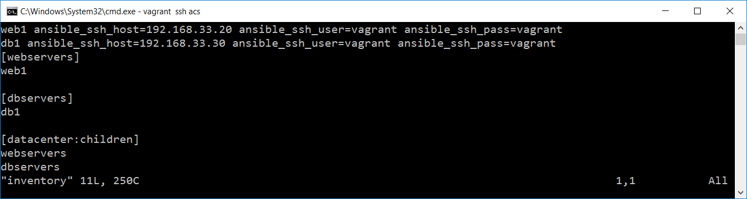

1. And run the same command with datacenter which has groups

**ansible datacenter -i inventory -m ping**

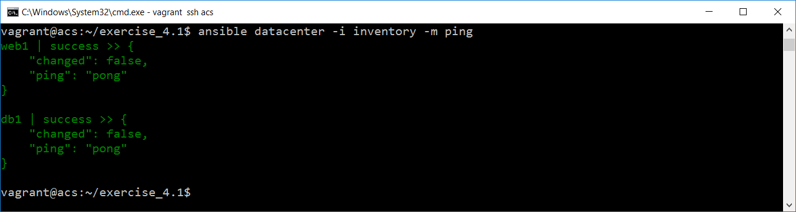

1. Add variables in the group which handle username and password

web1 ansible_ssh_host=192.168.33.20

db1 ansible_ssh_host=192.168.33.30

[webservers]

web1

[dbservers]

db1

[datacenter:children]

webservers

dbservers

[datacenter:vars]

ansible_ssh_user=vagrant

ansible_ssh_pass=vagrant

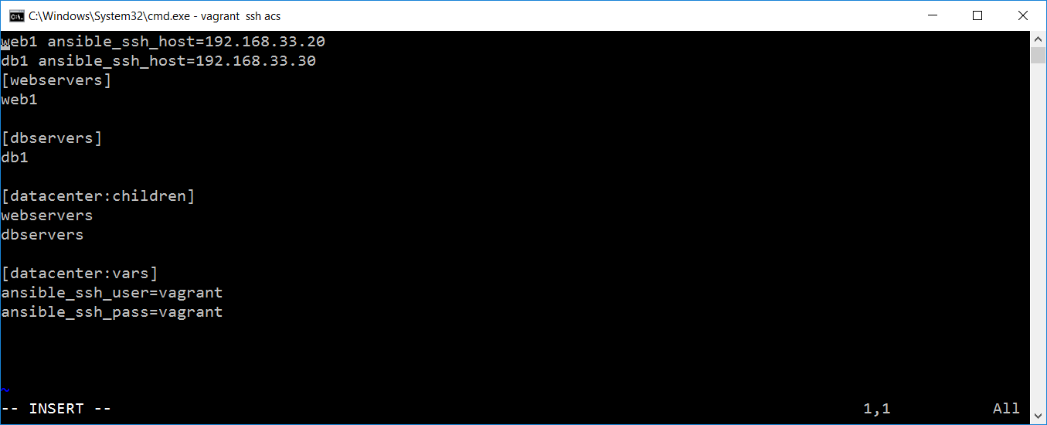

1. Now you can see both servers are still running with variables

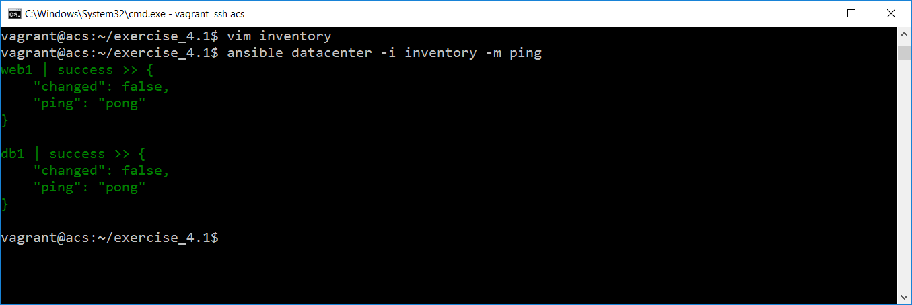

Note :

Install tree using below command

sudo apt-get install tree

to move previous directory use ../..

**Scale-out with multiple files:**

1. Create the following directory structure in exercise_4.2 directory

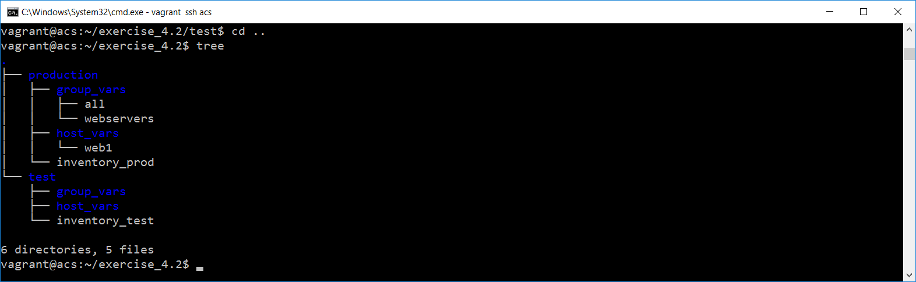

1. Create **inventory_prod** file as mentioned below:

web1 ansible_ssh_host=192.168.33.20

db1 ansible_ssh_host=192.168.33.30

[webservers]

web1

[dbservers]

db1

[datacenter:children]

webservers

dbservers

[datacenter:vars]

ansible_ssh_user=vagrant

ansible_ssh_pass=vagrant

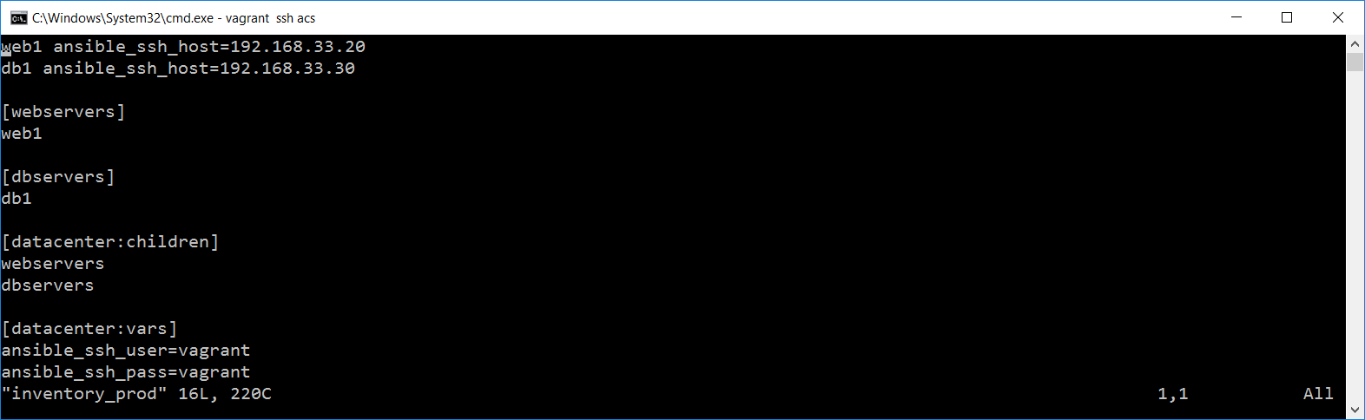

1. Add all file under production🡪group_vars directory, and add the content

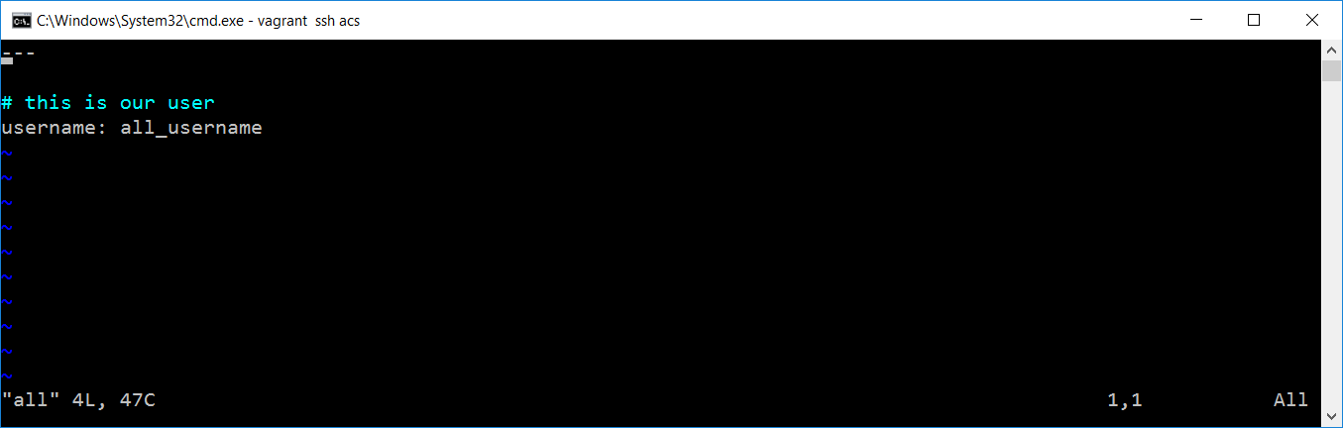

1. Add the below command in webservers file.

---

# This is a good habit to have

username: group_user

1. Create webservers file under group_vars

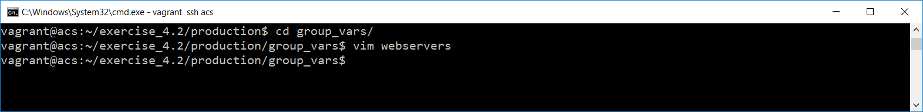

1. Add below content in the file

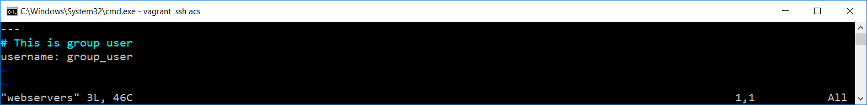

1. Run the following command under production directory:

**ansible webservers -i inventory_prod -m user -a "name={{username}} password=12345"**

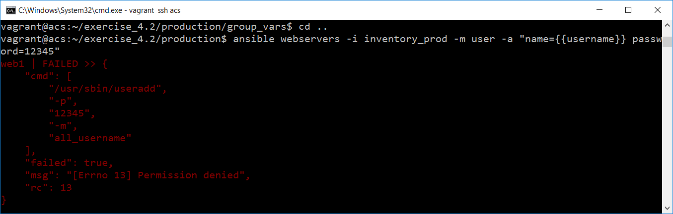

1. Enter the above command with –sudo to verify password

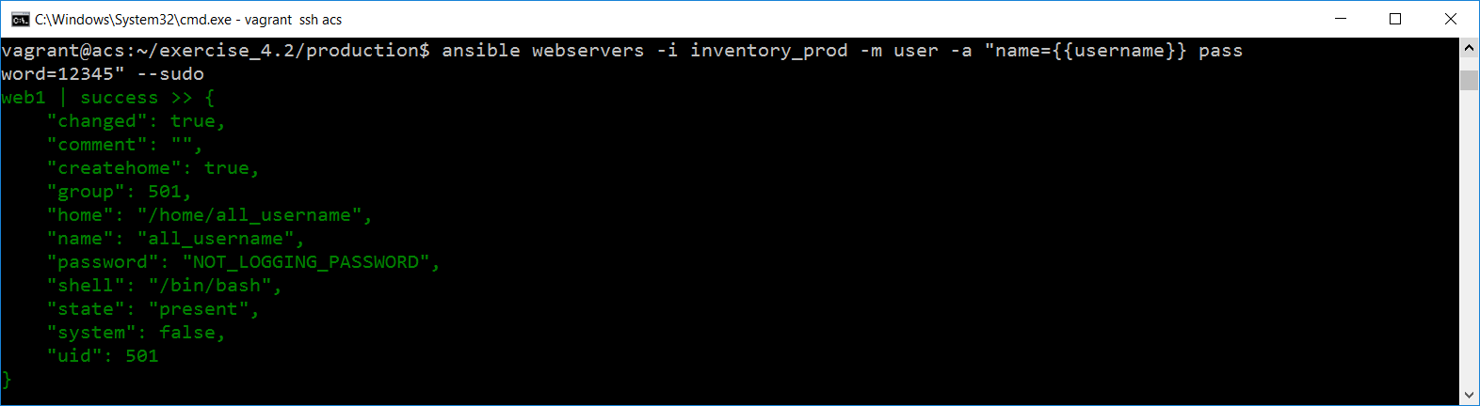

1. Now run the same command under production directory

**ansible webservers -i inventory_prod -m user -a "name={{username}} password=12345" --sudo**

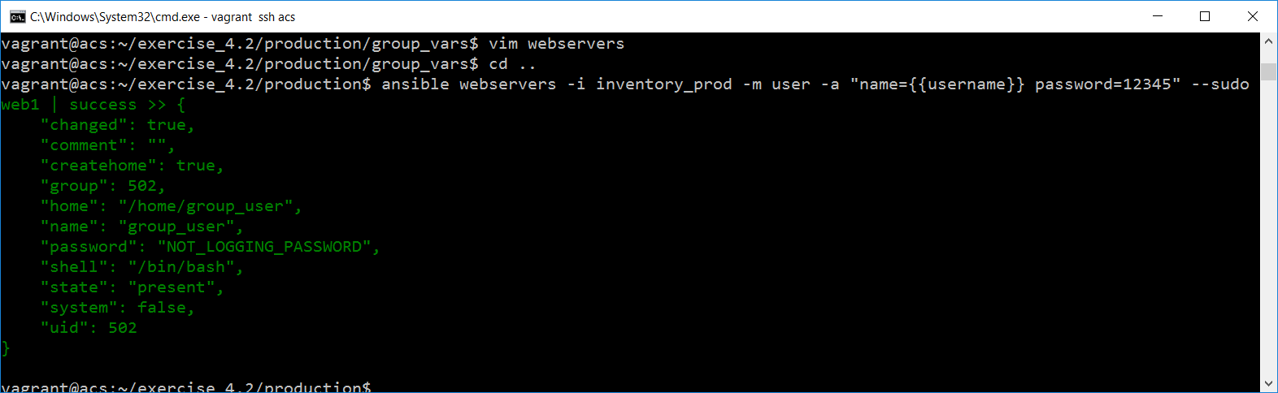

You can run the same command under group_vars directory using below command too..

**ansible webservers -i ../inventory_prod -m user -a "name={{username}} password=12345" --sudo**

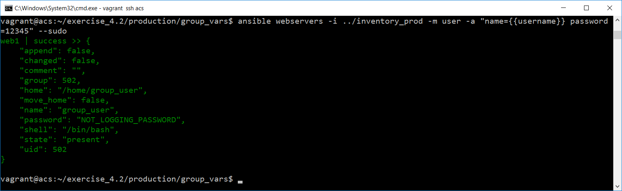

1. Move to host_vars directory and enter create file called web1. Fill the following content

---

# web1 user

username: web1_user

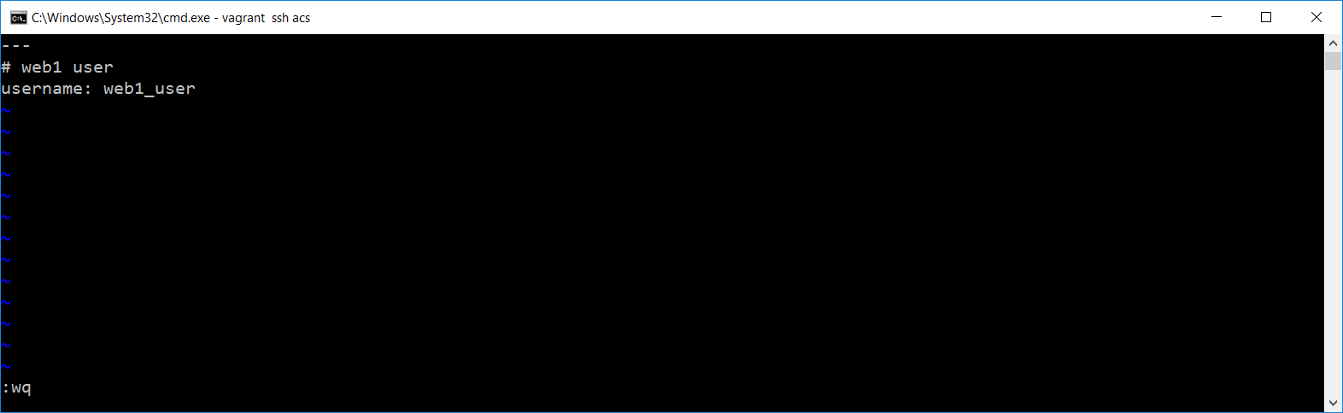

1. Now run the same command it will use web1_user

**ansible webservers -i ../inventory_prod -m user -a "name={{username}} password=12345" --sudo**

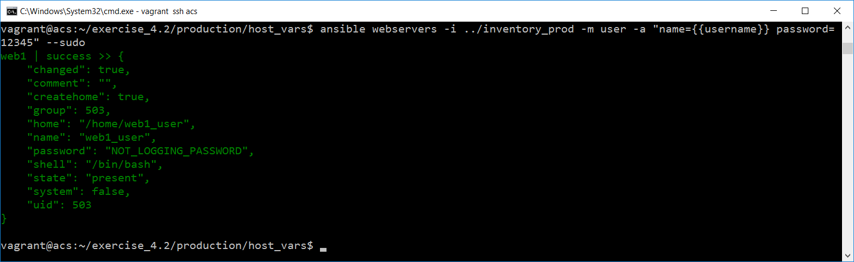

**Ansible Configurations:**

Note: Copy the directory using below command

**Syntax: cp -r source/ ~/destination/**

**cp -r production/ ~/exercise_4.3/**

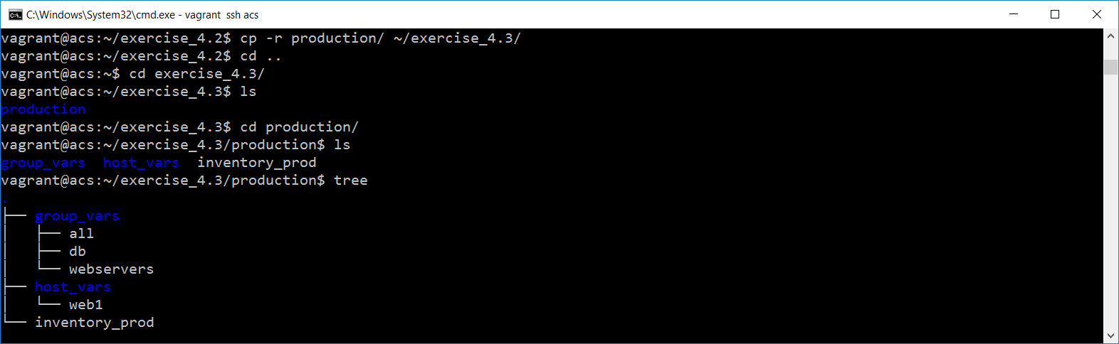

1. Create new directory called exercise_4.3 and copy production directory from exercise_4.2 to exercise_4.3 as mentioned above.
2. Enter below command, to open known_host file

**vim ~/.ssh/known_hosts**

***Note: Type dG to delete all the lines.***

1. Enter below command

**ansible web1 -i inventory_prod -m ping**

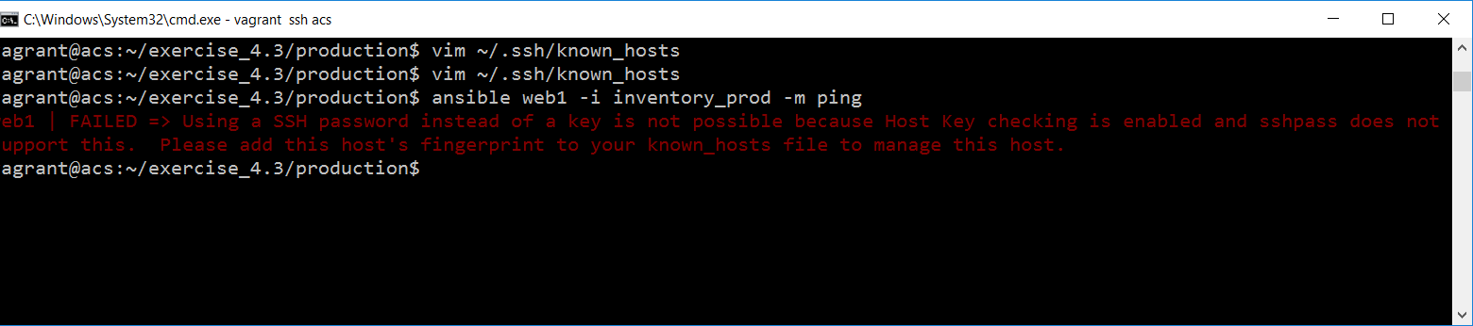

It will raise error as shown above.

1. Open configuration file in your editor:
   * **vim ansible.cfg**
   * **Fill the file with following details**

[defaults]

host_key_checking=False

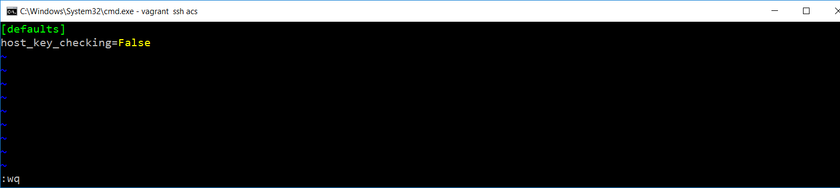

1. You can check the known_hosts file it has nothing by using “**cat ~/.ssh/known_hosts**” command.

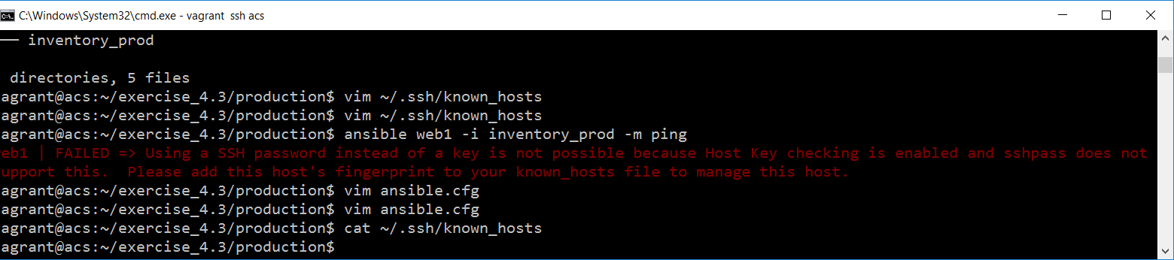

1. Now if you enter the above command it will work:

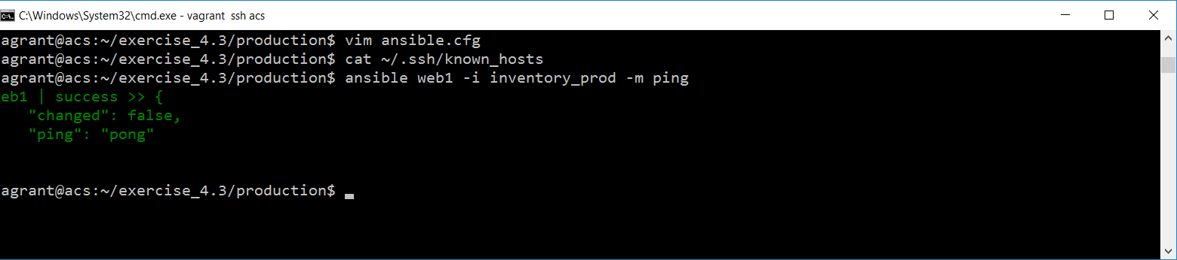

1. Check your known_hosts once again, you will be getting the key, because ansible automatically set yes for the key. Hence we get the finger print key here.

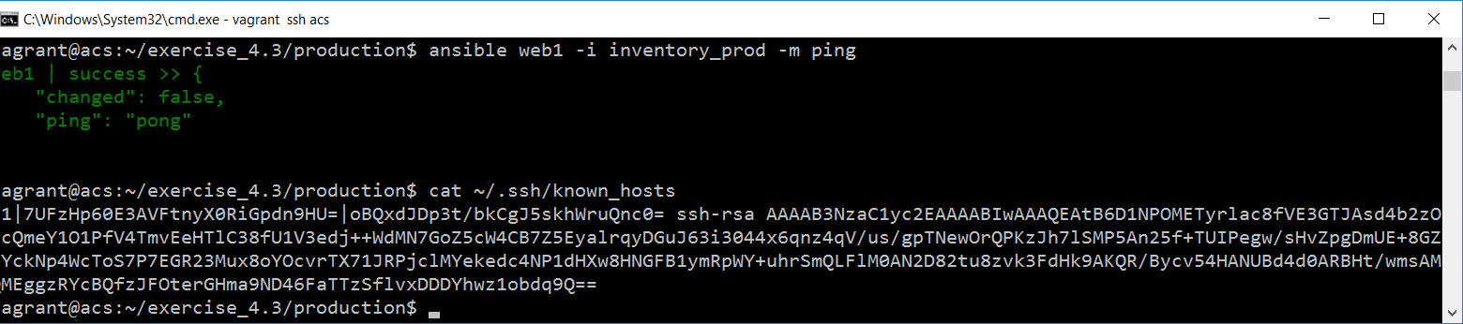

1. Now we are going to overwrite this configuration with environment variables.
2. Open the known_hosts file in vim editor

**vim ~/.ssh/known_hosts**

1. And delete all content within it.
2. Check ansible.cfg file using cat command
3. Now modify the variable **ANSIBLE_HOST_KEY_CHECKING**

**export ANSIBLE_HOST_KEY_CHECKING=True**

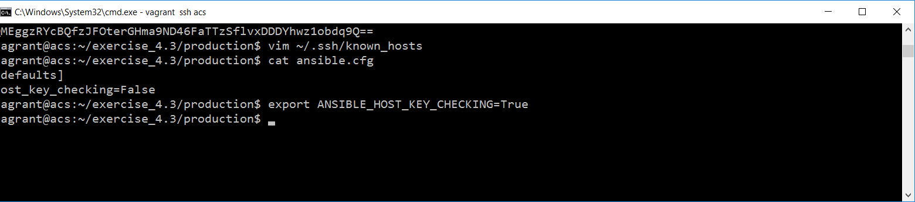

1. Check ANSIBLE_HOST_KEY_CHECKING variable using echo command

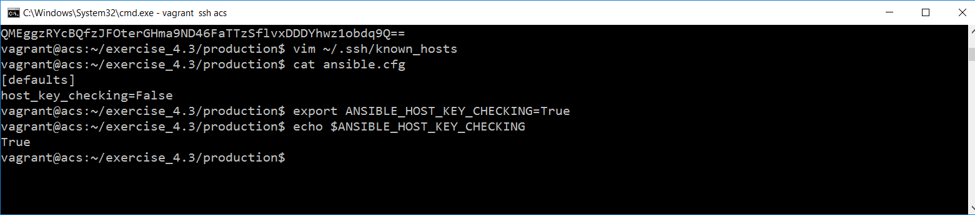

1. If you enter ansible adhoc command now, it will fail

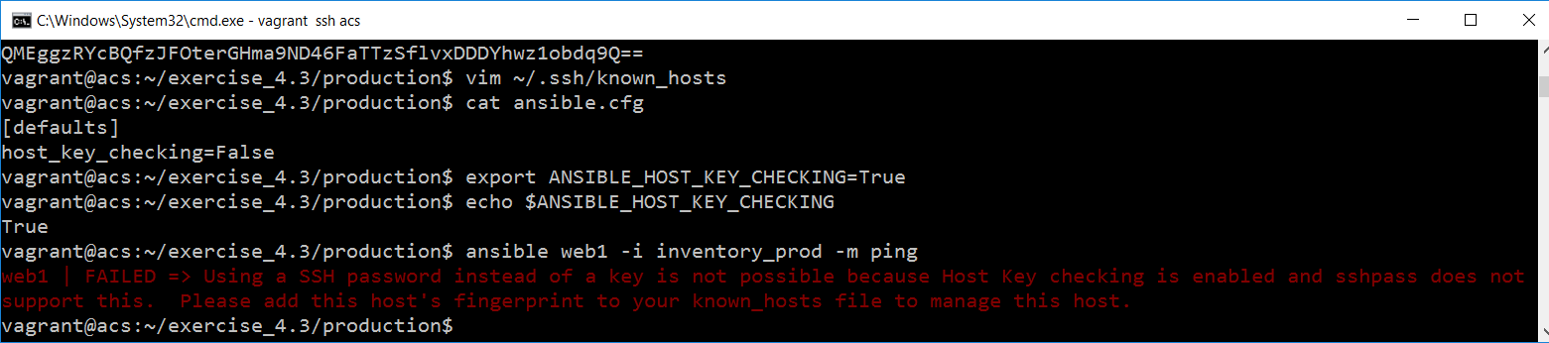

1. Because in my current directory I have the configuration file set to false. [It does fail, because the environment variable is taking precedence over the configuration option set in my current directory.](https://app.pluralsight.com/player?course=hands-on-ansible&author=aaron-paxson&name=hands-on-ansible-m4&clip=6&mode=live&start=393)

**Ansible Modules : Using Module Docs and Yum Module**

1. Start acs server

**vagrant ssh acs**

1. Create new directory called exercise_5.1
2. Add inventory file with following content

web1 ansible_ssh_host=192.168.33.20 ansible_ssh_user=vagrant ansible_ssh_pass=vagrant username=ansible_user

db1 ansible_ssh_host=192.168.33.30

[webservers]

web1

[dbservers]

db1

[datacenter:children]

webservers

dbservers

[datacenter:vars]

ansible_ssh_user=vagrant

ansible_ssh_pass=vagrant

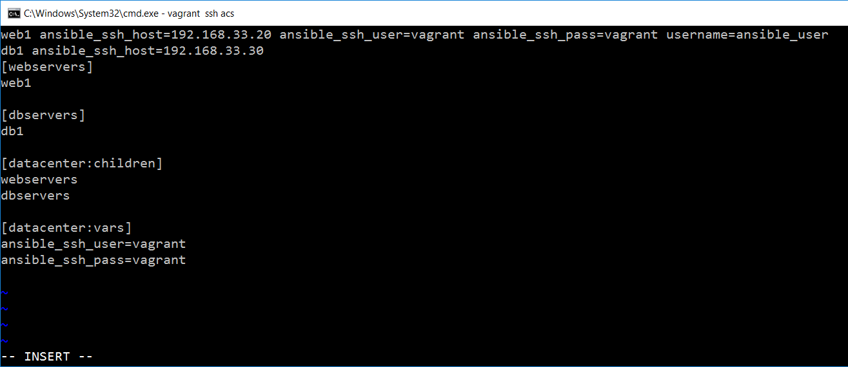

1. Enter ansible doc command to check all the commands

**ansible-doc -l**

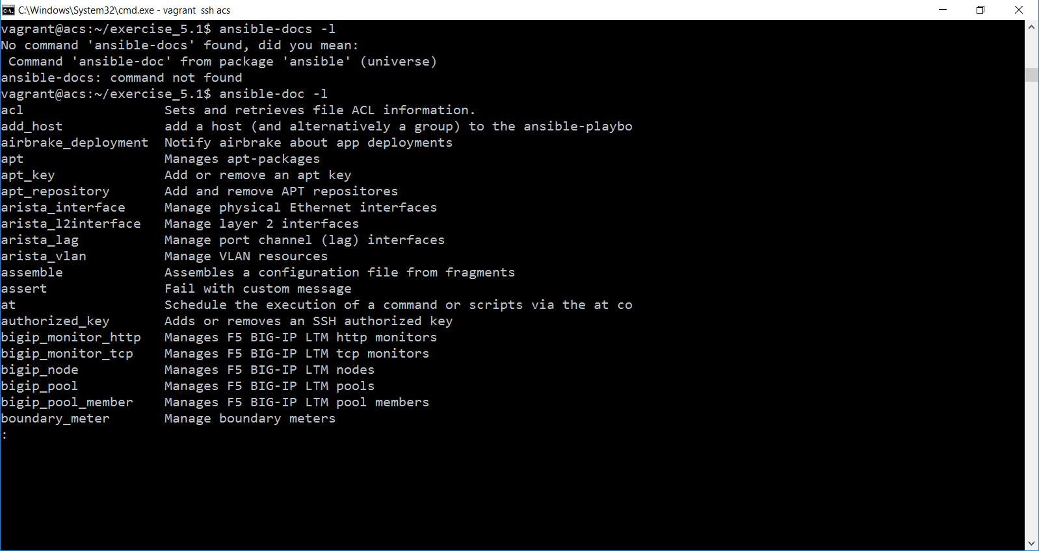

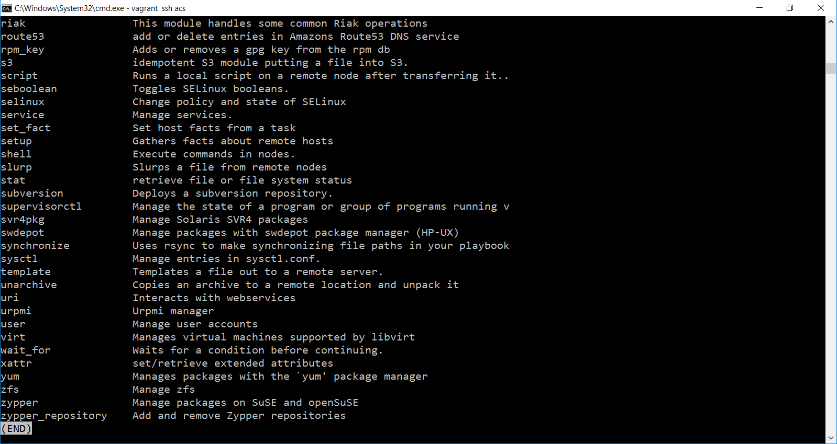

1. Enter yum to check complete description about yum command in ansible-doc

**ansible-doc yum**

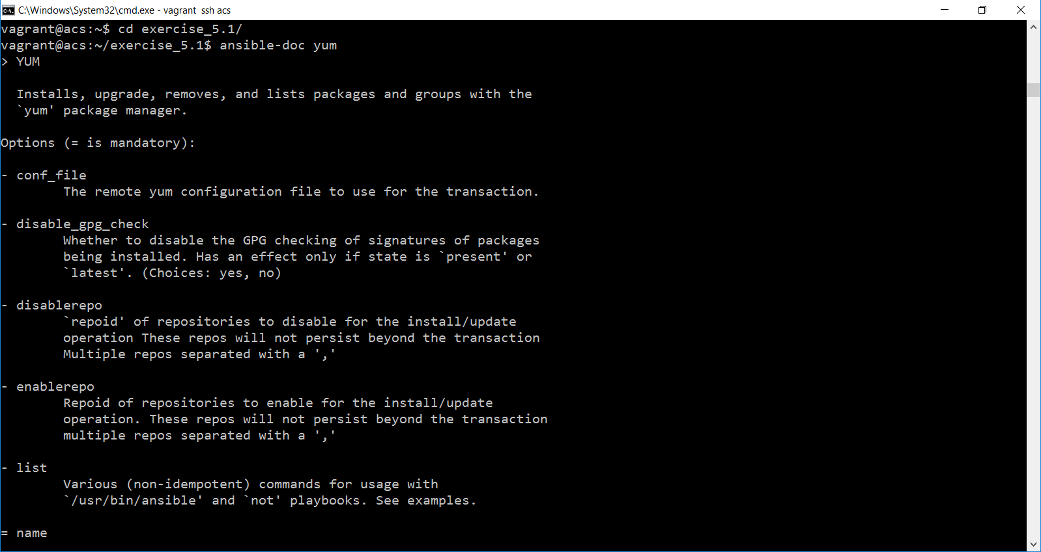

1. Enter below command to install apache httpd

**ansible webservers -i inventory -m yum -a "name=httpd state=present"**

1. If you get any error message like below, re-enter the command appended with –sudo

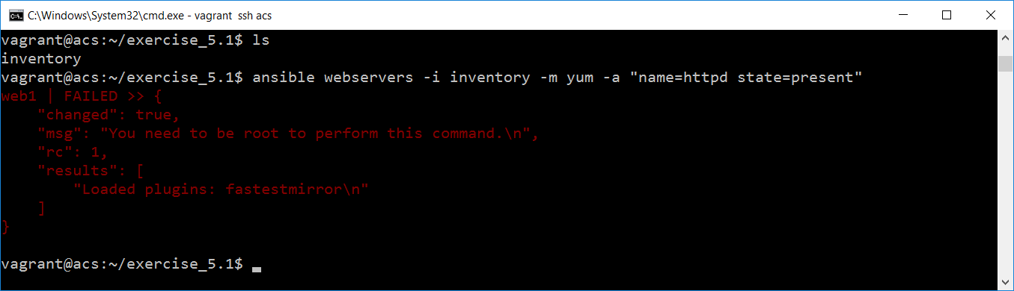

**ansible webservers -i inventory -m yum -a "name=httpd state=present" --sudo**

1. Now you will get the result as mentioned below:
2. If you see the result you can understand web1 started successfully and changed = true, this because of state has been mentioned as present.

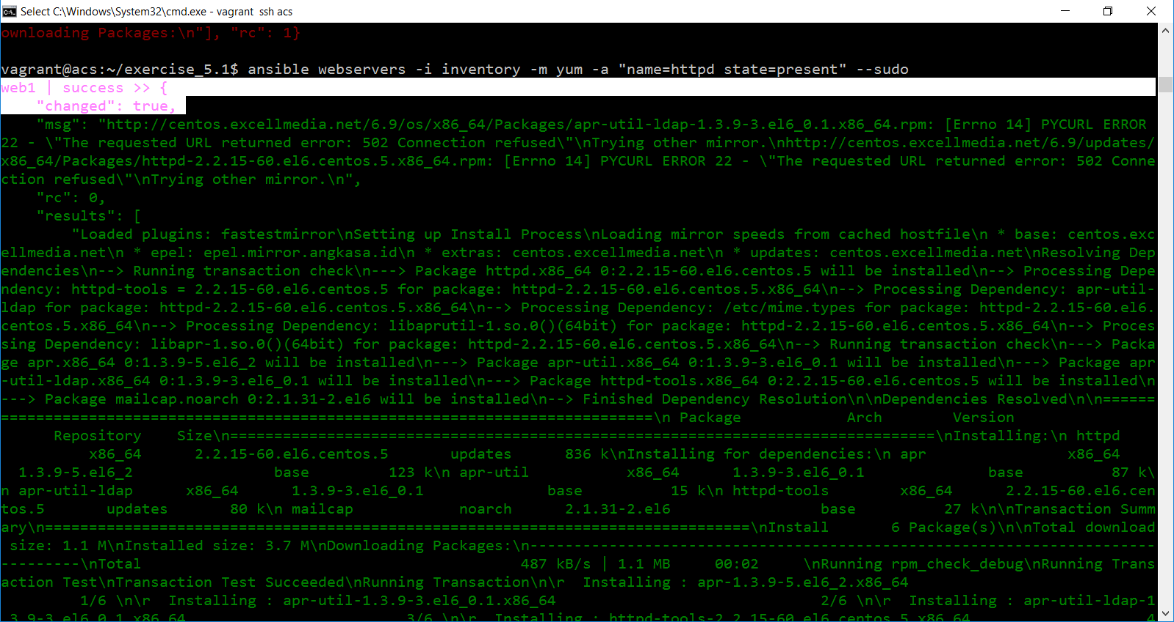

1. If you re-run the same command again you can see changed = false. Because not changes this time.

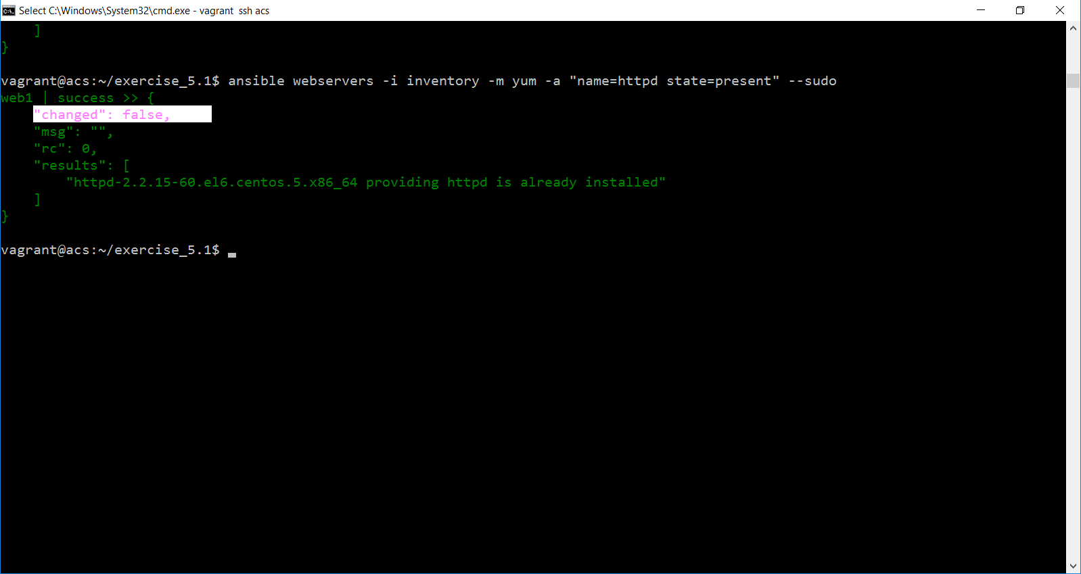

1. Add service in your command. To check the service parameters enter ansible-doc command which will help you to add parameters:

ansible-doc service

1. Start the service using below command

**ansible webservers -i inventory -m service -a "name=httpd enabled=yes state=started" --sudo**

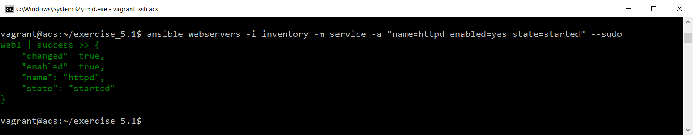

1. Start sql server in db1

ansible dbservers -i inventory -m yum -a "name=mysql-server state=present" --sudo

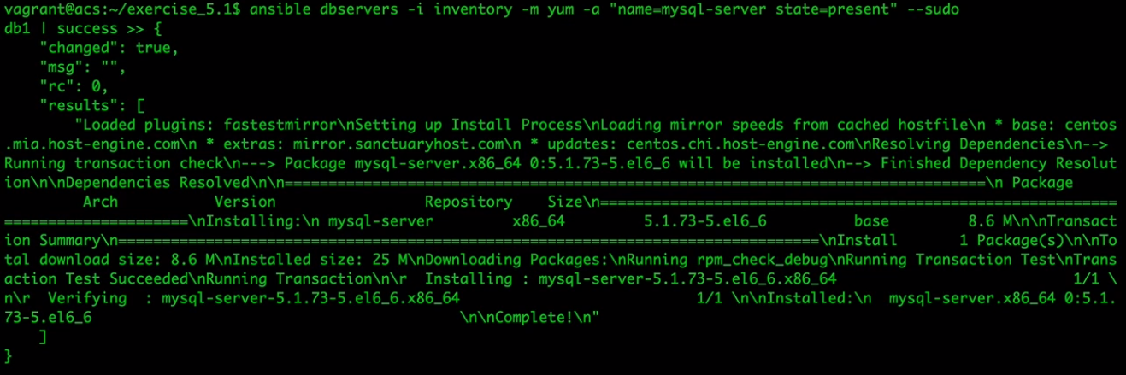

1. To start the service use below:

ansible dbservers -i inventory -m service -a "name=mysqld state=started" --sudo

To ensure sql server is working fine, just connect db1 in another terminal by using “vagrant ssh db”. And enter below commands:

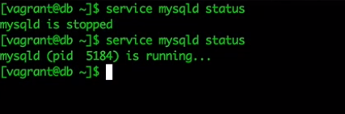

1. To stop all services in webservers and dbservers enter below command:

**ansible webservers:dbservers -i inventory -m service -a "name=iptables state=stopped" --sudo**

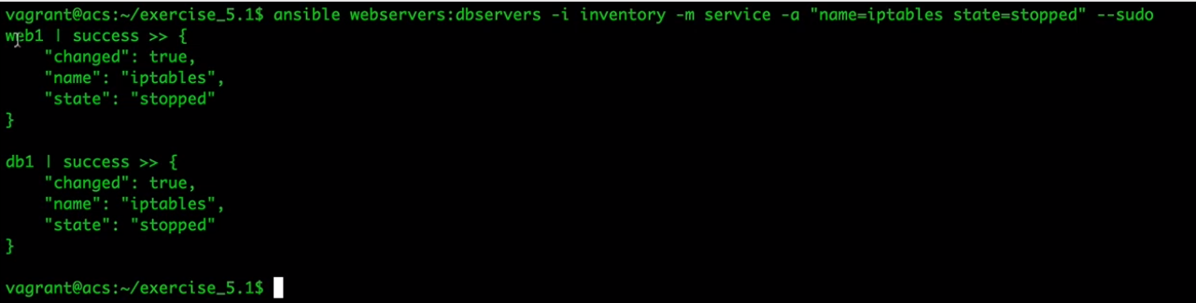

1. Now enter your webserver ipaddress in the browser you will get:

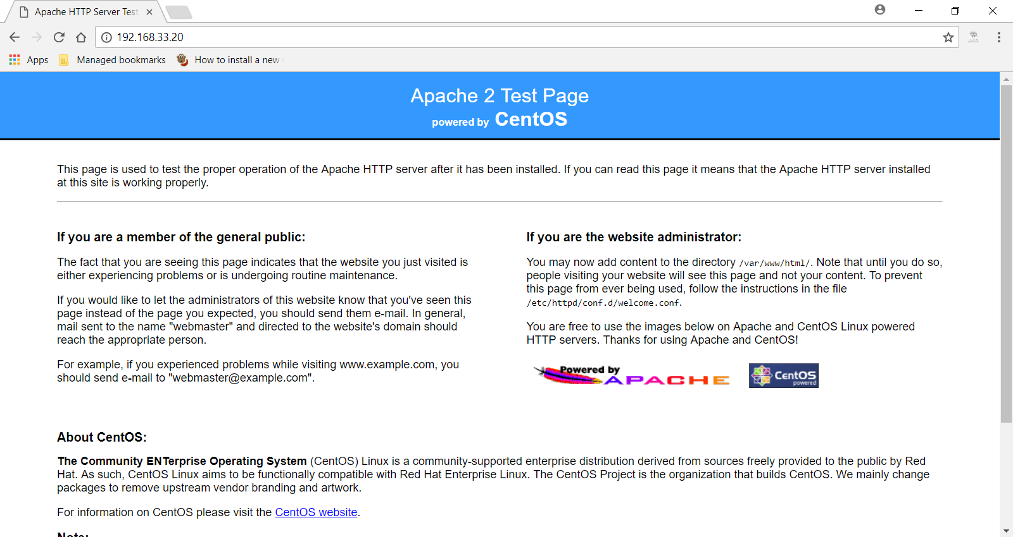

Using Setup Module:

Gather facts on remote systems

Used in playbooks

1. Enter below command:

ansible web1 -i inventory -m setup

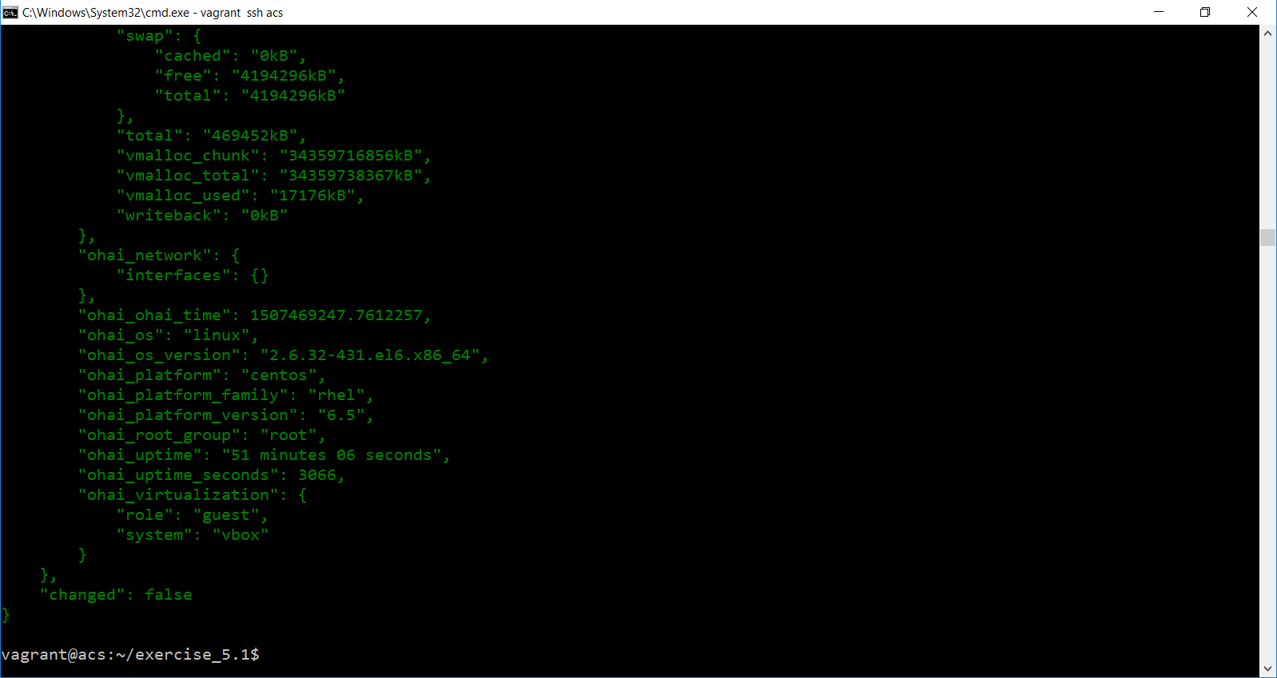

1. Enter below command with parameter eth*

ansible web1 -i inventory -m setup -a "filter=ansible_eth*"

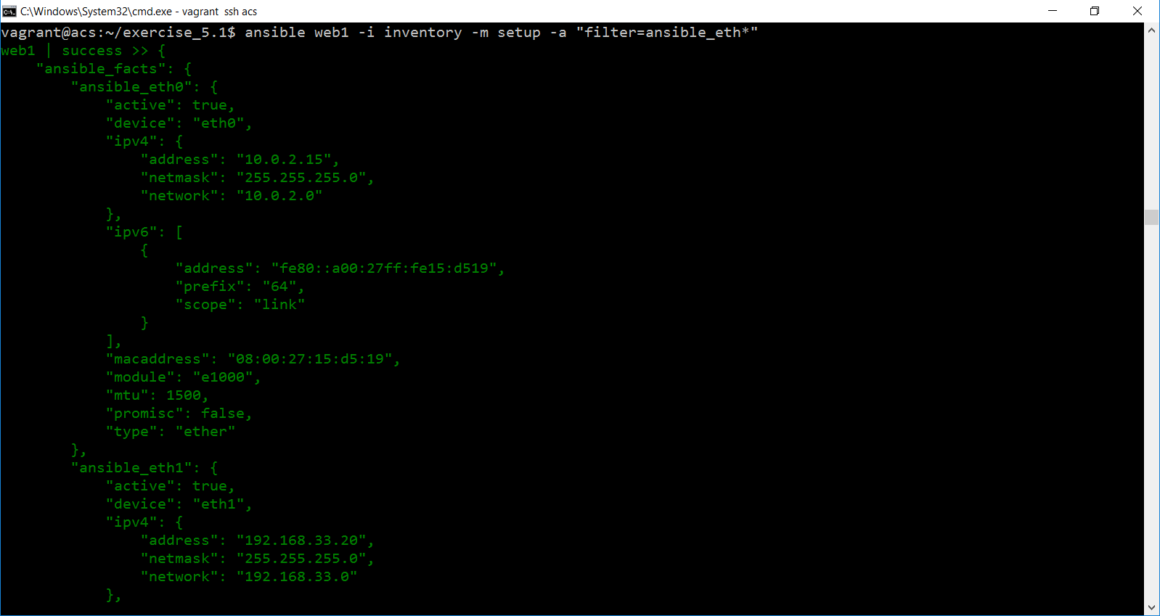

1. To check hard drives running on these machine enter below command:

ansible web1 -i inventory -m setup -a "filter=ansible_mounts"

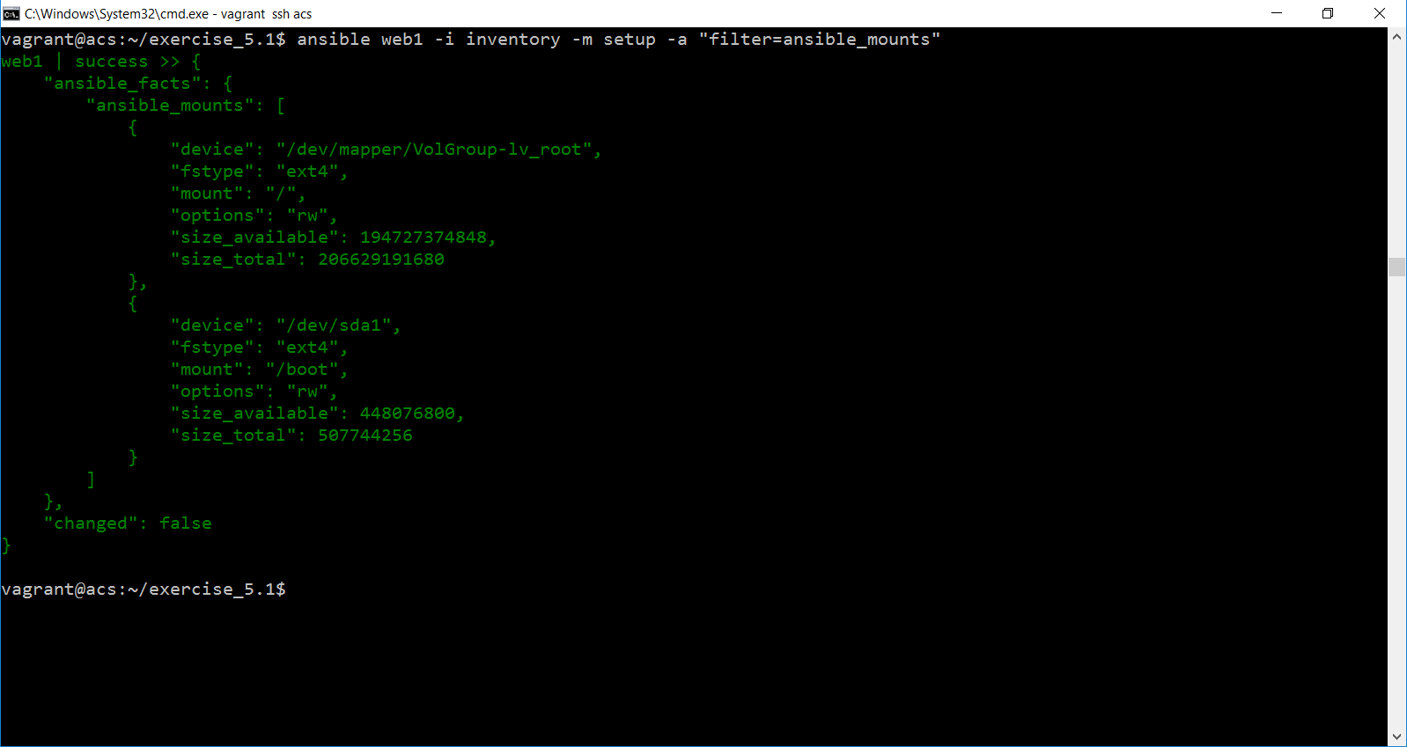

1. The below command help you to see details about all machines in inventory file. And information will be stored in setup directory.

ansible all -i inventory -m setup --tree ./setup

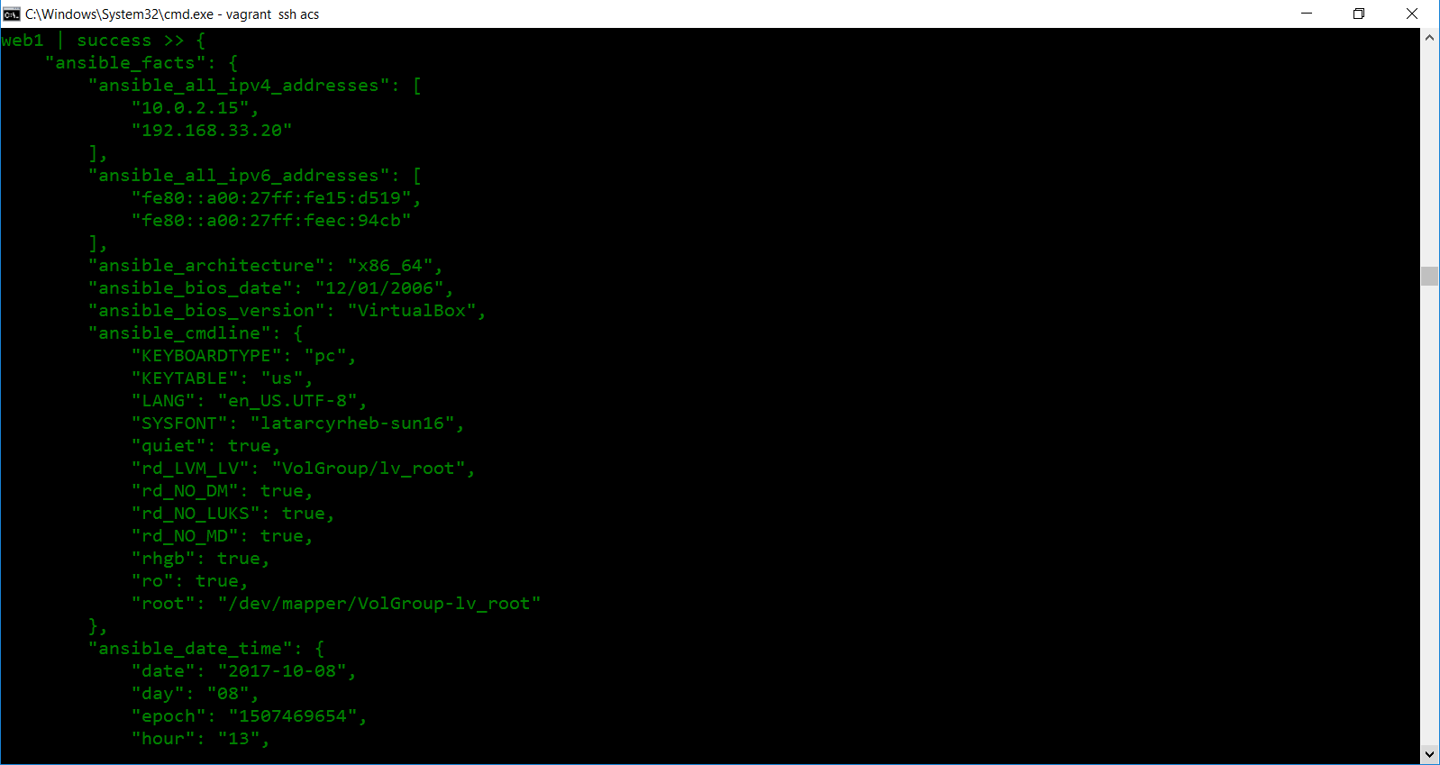

1. Open setup directory
2. You can see db1 and web1 files

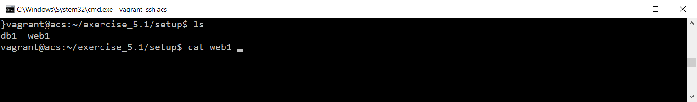

1. You can see the information in the file called db1, web1

Playbook

1. Connect acs server

vagrant ssh acs

1. Create exercise_6.1 directory which include ansible.cfg file and inventory file as mentioned below:

**ansible.cfg:**

[defaults]

hostfile = inventory

**inventory**

acs ansible_ssh_host=192.168.33.10 ansible_ssh_user=vagrant ansible_ssh_pass=vagrant

web1 ansible_ssh_host=192.168.33.20 ansible_ssh_user=vagrant ansible_ssh_pass=vagrant username=ansible_user

db1 ansible_ssh_host=192.168.33.30

[webservers]

web1

[dbservers]

db1

[datacenter:children]

webservers

dbservers

[datacenter:vars]

ansible_ssh_user=vagrant

ansible_ssh_pass=vagrant

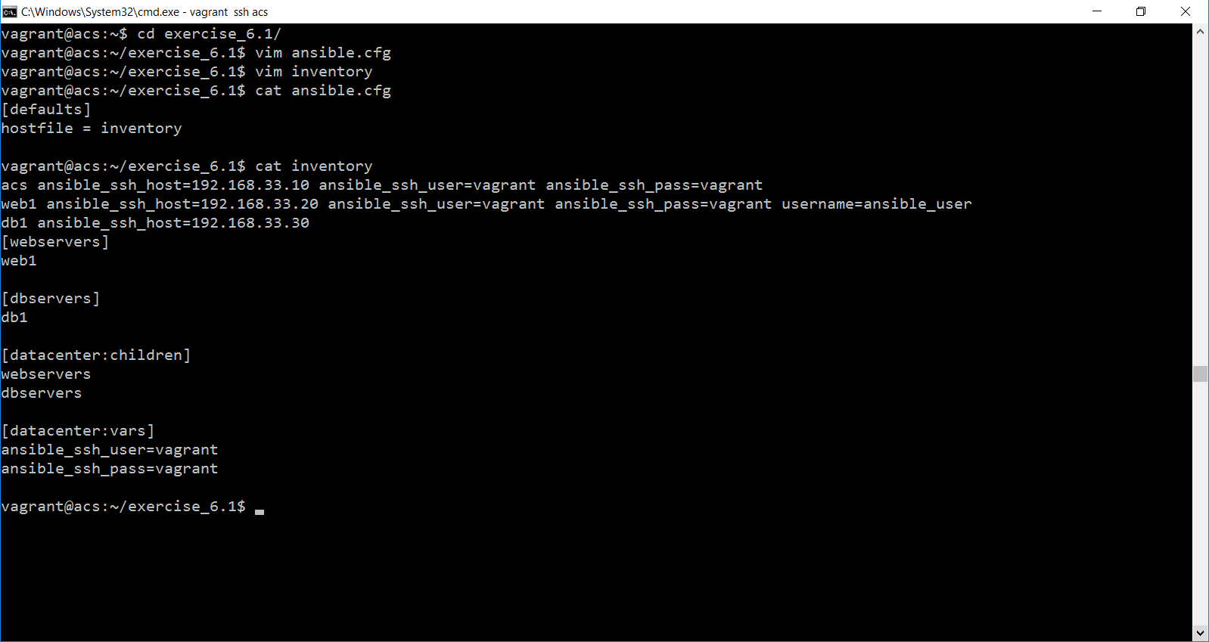

1. Create one yaml file called **web_db.yaml** with following tasks:

**web_db.yaml**

---

- hosts: webservers

sudo: yes

tasks:

- name: Ensure that Apache is installed

yum: name=httpd state=present

- name: Start Apache Services

service: name=httpd enabled=yes state=started

- hosts: dbservers

sudo: yes

tasks:

- name: Ensure MySQL is installed

yum: name=mysql-server state=present

- name: Start MySQL

service: name=mysqld state=started

- hosts: webservers:dbservers

sudo: yes

tasks:

- name: Stop IPTABLES NOW!!!

service: name=iptables state=stopped

1. Now enter the below playbook command:

ansible-playbook web_db.yaml

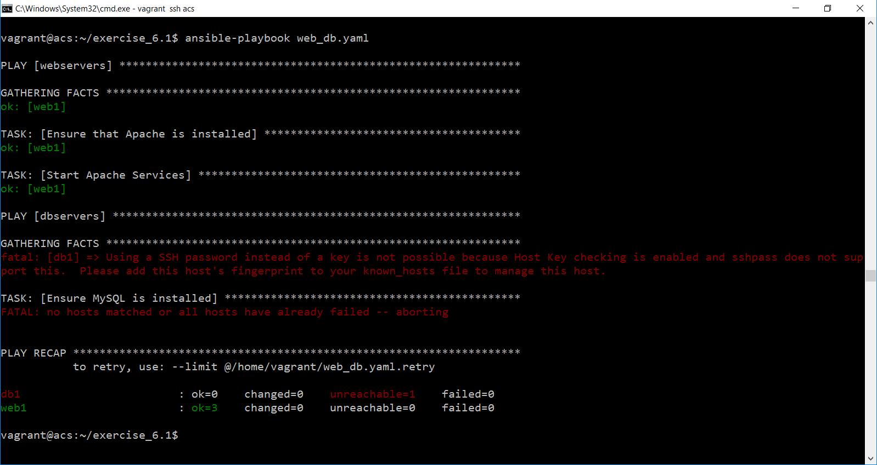

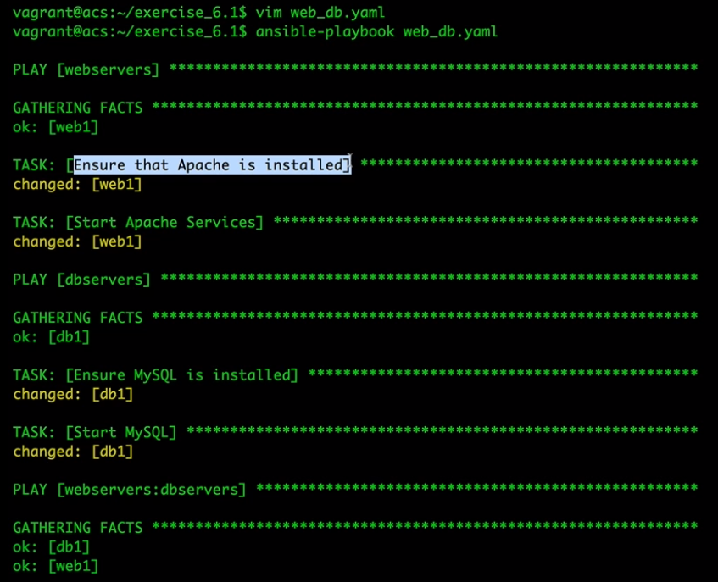

1. In inventory file remove all datacenter variables and run the same command:

**inventory**

acs ansible_ssh_host=192.168.33.10 ansible_ssh_user=vagrant ansible_ssh_pass=vagrant

web1 ansible_ssh_host=192.168.33.20 ansible_ssh_user=vagrant ansible_ssh_pass=vagrant username=ansible_user

db1 ansible_ssh_host=192.168.33.30

[webservers]

web1

[dbservers]

db1

[datacenter:children]

webservers

dbservers

[datacenter:vars]

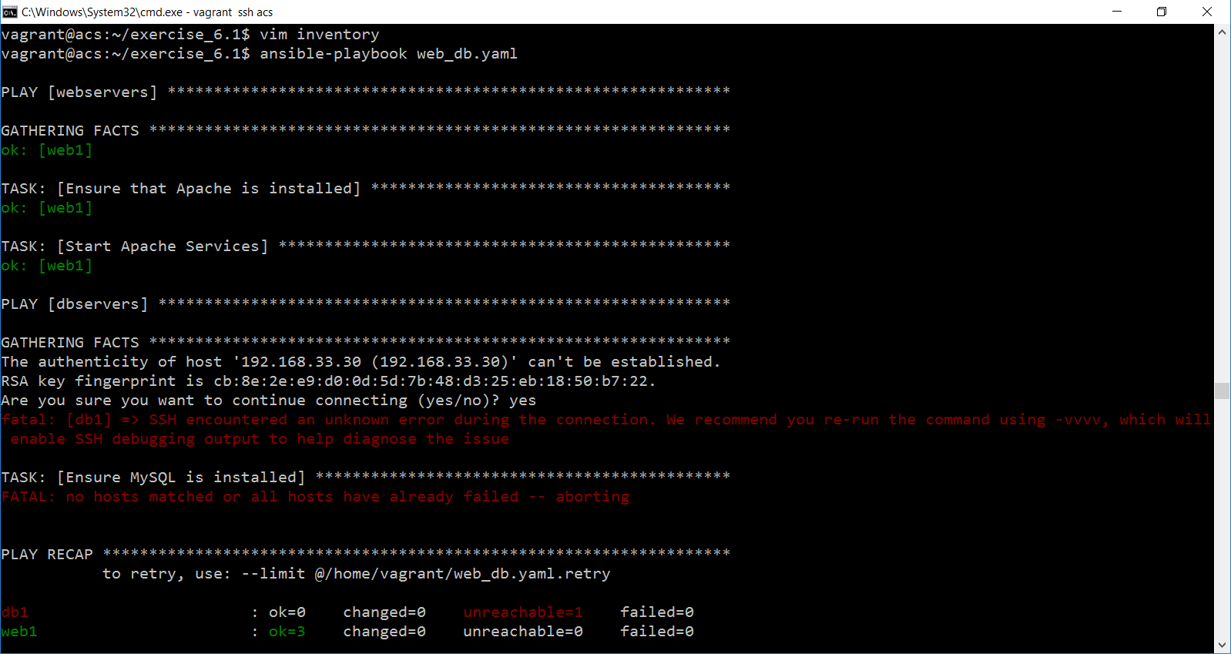

1. Now once again add the variables and enter below command with –limit flag

ansible-playbook web_db.yaml --limit @/home/vagrant/web_db.yaml.retry

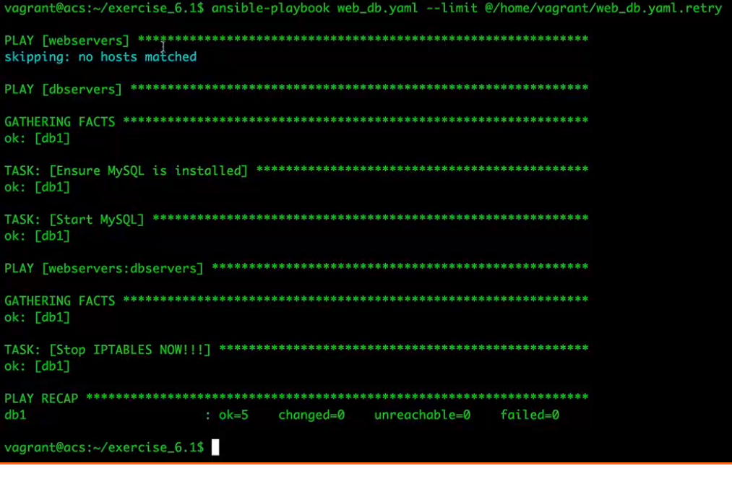

Playbook Controls

1. Add **ansible_os_family** details in the playbook
2. Add new task called **Deploy configuration File**
3. Add **handlers** and also add one more task called **Copy site Files**
4. Add **vars** for the above configuration

**Web_db.yml**

---

- hosts: webservers

sudo: yes

vars:

http_port: 80

doc_dir: /ansible/

doc_root: /var/www/html/ansible/

max_clients: 5

vars_prompt:

- name: username

prompt: What is your name? What is your Quest? What is your fav color?

tasks:

- name: Ensure that Apache is installed

yum: name=httpd state=present

when: ansible_os_family == "RedHat"

- name: Start Apache Services

service: name=httpd enabled=yes state=started

- name: Deploy configuration File

template: src=templates/httpd.j2 dest=/etc/httpd/conf/httpd.conf

notify:

- Restart Apache

- name: Copy Site Files

template: src=templates/index.j2 dest={{ doc_root }}/index.html

handlers:

- name: Restart Apache

service: name=httpd state=restarted

- hosts: dbservers

sudo: yes

tasks:

- name: Ensure MySQL is installed

yum: name=mysql-server state=present

when: ansible_os_family == "RedHat"

- name: Start MySQL

service: name=mysqld state=started

- hosts: webservers:dbservers

sudo: yes

tasks:

- name: Stop IPTABLES NOW!!!

service: name=iptables state=stopped

1. Create new directory called templates under exercise_6.1 folder.
2. Copy httpd.j2 and index.j2 file which I have shared with you.
3. Once the above playbook executed successfully, you can see the result in your browser by entering the following command:

192.168.33.20:80/ansible

1. This will open your index.html file with filled parameters which you have entered in the prompt.

**TroubleShoot**

In case if you get below error:

Create directory called Ansible in web1 server under /var/www/html directory.

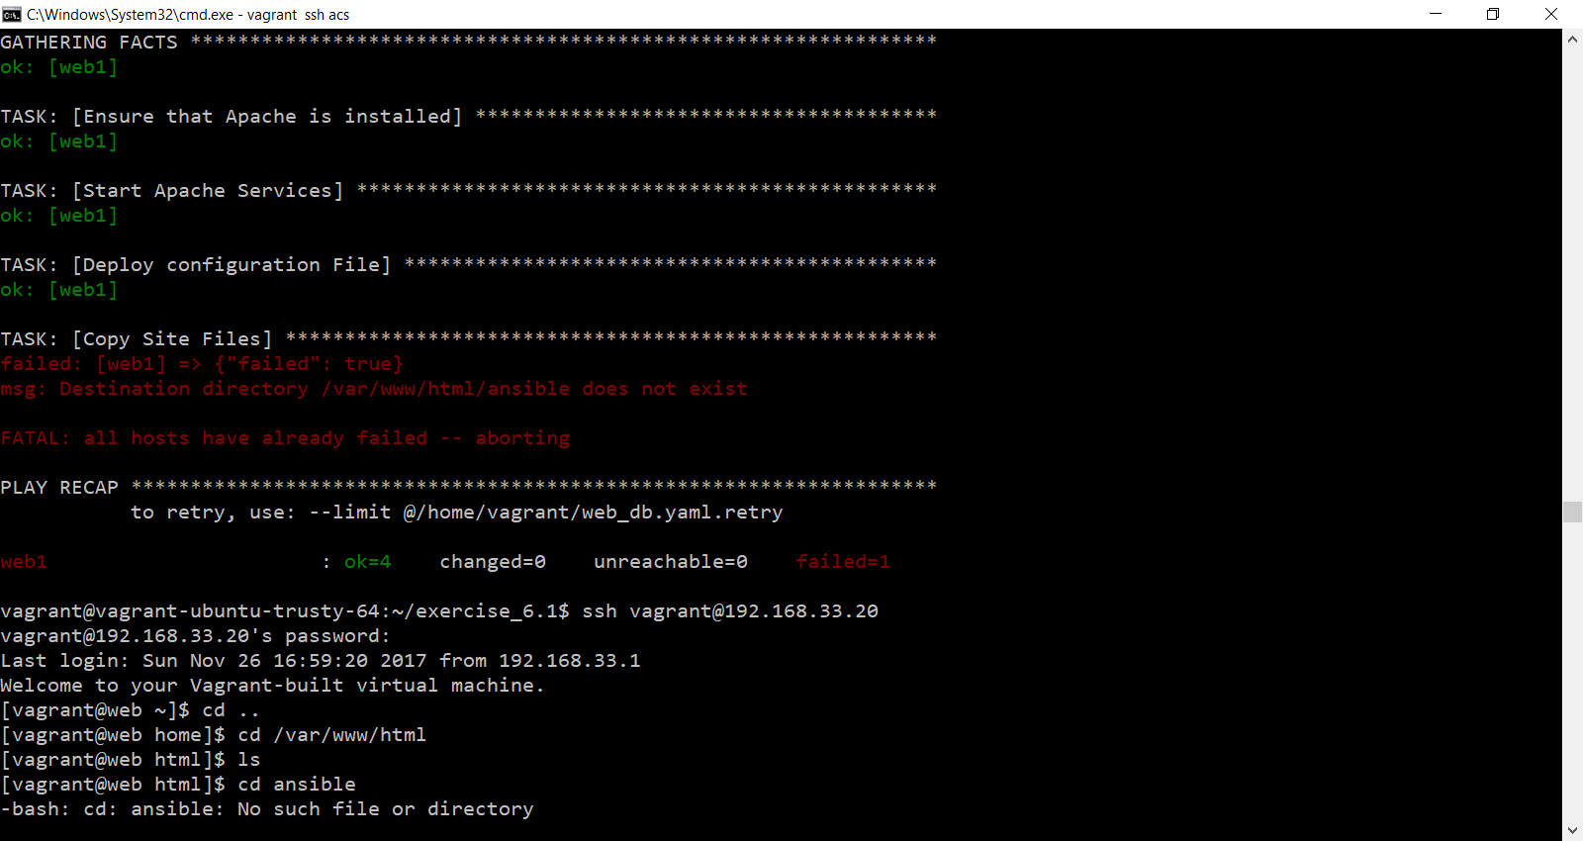

Roles

1. Start acs server

vagrant ssh acs

1. Add one new directory with name exercise_7.1
   * mkdir exercise_7.1
   * create the following directory and files:



1. look at your ansible.cfg file below

**ansible.cfg**

[defaults]

hostfile = inventory

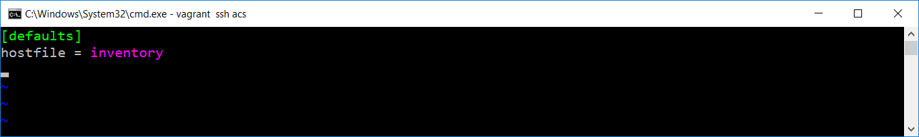

1. inventory file as follows:

**inventory**

acs ansible_ssh_host=192.168.33.10 ansible_ssh_user=vagrant ansible_ssh_pass=vagrant

web1 ansible_ssh_host=192.168.33.20 ansible_ssh_user=vagrant ansible_ssh_pass=vagrant username=ansible_user

db1 ansible_ssh_host=192.168.33.30

[webservers]

web1

[dbservers]

db1

[datacenter:children]

webservers

dbservers

[datacenter:vars]

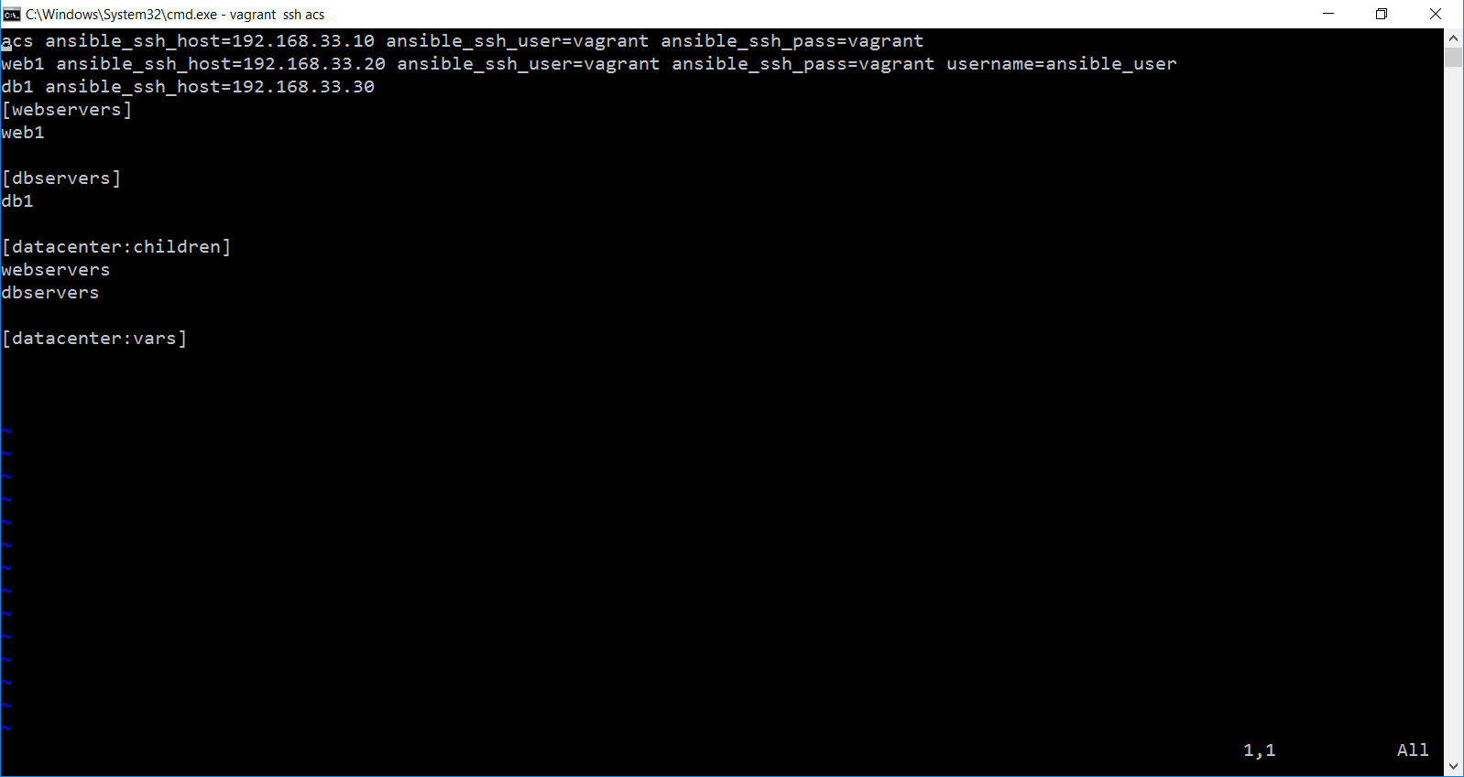

1. And your webserver.yml file as mentioned below:

**webserver.yml**

---

## Web Servers

- hosts: webservers

roles:

- webserver

sudo: yes

gather_facts: no

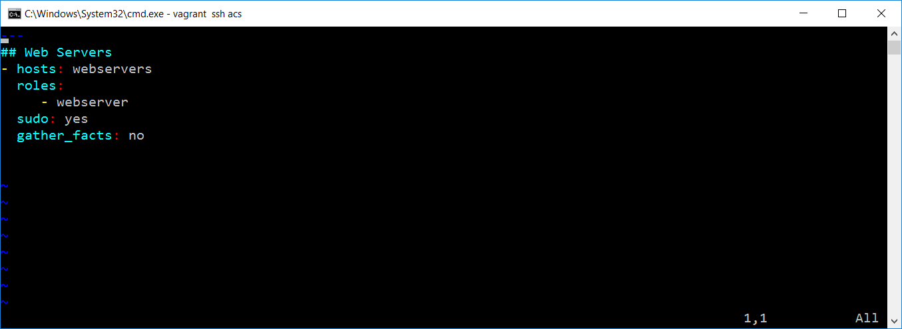

1. We have one roles directory include all files and folders as mentioned below:

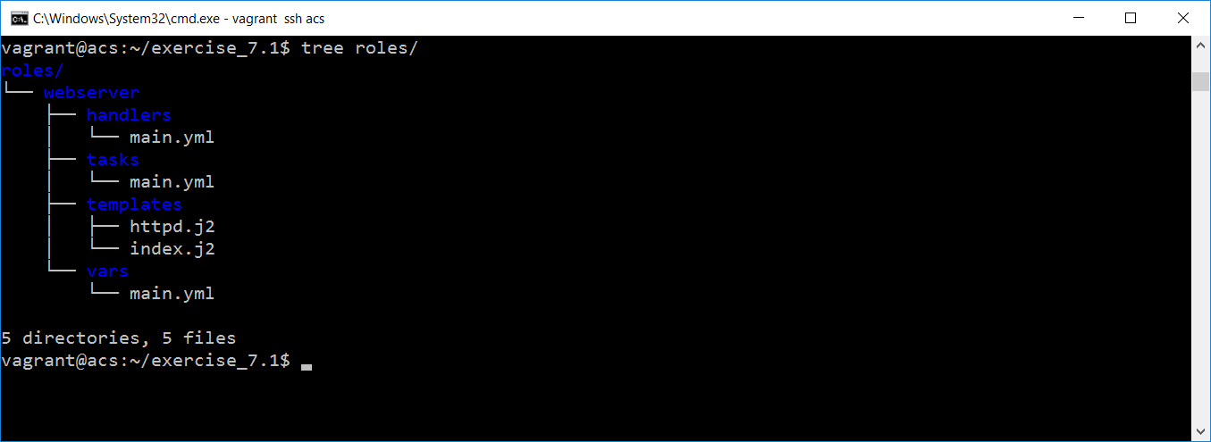

1. Add below code under roles/webserver/handlers 🡪 main.yml file

**main.yml**

- name: Restart Apache

service: name=httpd state=restarted

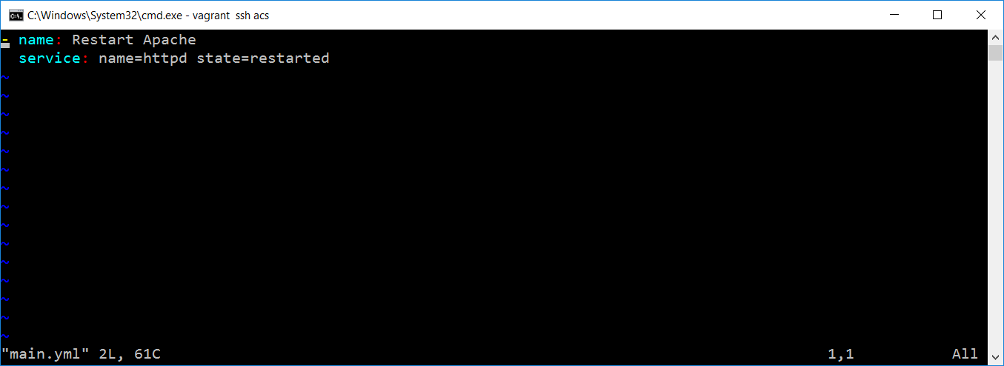

1. Add below code under roles/webserver/tasks 🡪 main.yml file

**main.yml**

---

- name: Ensure that Apache is installed

yum: name=httpd state=present

- name: Start Apache Services

service: name=httpd enabled=yes state=started

- name: Deploy configuration File

template: src=httpd.j2 dest=/etc/httpd/conf/httpd.conf

notify:

- Restart Apache

- name: Copy Site Files

template: src=index.j2 dest={{ doc_root }}/index.html

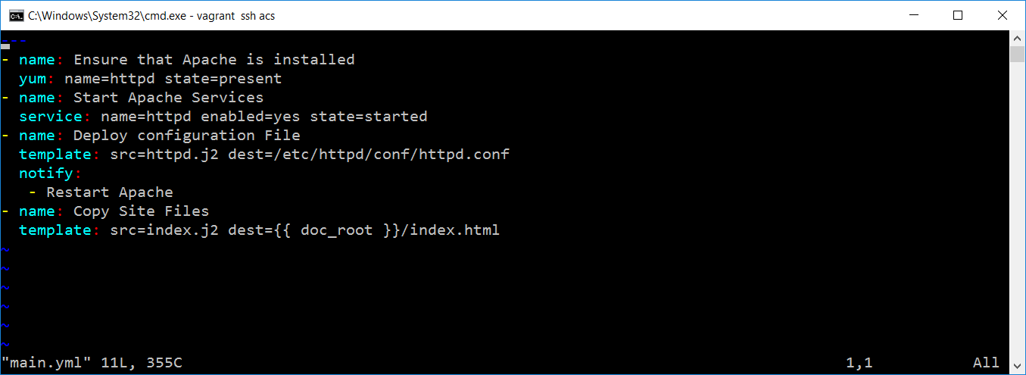

1. Add below code under roles/webserver/vars 🡪 main.yml file

**main.yml**

---

http_port: 80

doc_dir: /ansible/

doc_root: /var/www/html/ansible/

max_clients: 5

username: My Name is Viji...

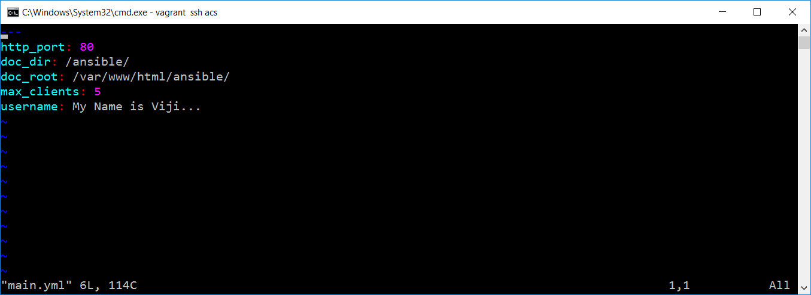

1. Add below code under roles/webserver/templates 🡪 httpd.j2 and index.j2 file

**httpd.j2**

ServerTokens OS

ServerRoot "/etc/httpd"

PidFile run/httpd.pid

Timeout 60

KeepAlive Off

MaxKeepAliveRequests 100

KeepAliveTimeout 15

<IfModule prefork.c>

StartServers 8

MinSpareServers 5

MaxSpareServers 20

ServerLimit 256

MaxClients 256

MaxRequestsPerChild 4000

</IfModule>

<IfModule worker.c>

StartServers 4

# Adding --max_clients-- template variable

MaxClients {{ max_clients }}

MinSpareThreads 25

MaxSpareThreads 75

ThreadsPerChild 25

MaxRequestsPerChild 0

</IfModule>

# Adding Ansible --doc_dir-- and --doc_root-- variables

Alias {{ doc_dir }} {{ doc_root }}

# Adding port number --http_port--

Listen {{ http_port }}

LoadModule auth_basic_module modules/mod_auth_basic.so

LoadModule auth_digest_module modules/mod_auth_digest.so

LoadModule authn_file_module modules/mod_authn_file.so

LoadModule authn_alias_module modules/mod_authn_alias.so

LoadModule authn_anon_module modules/mod_authn_anon.so

LoadModule authn_dbm_module modules/mod_authn_dbm.so

LoadModule authn_default_module modules/mod_authn_default.so

LoadModule authz_host_module modules/mod_authz_host.so

LoadModule authz_user_module modules/mod_authz_user.so

LoadModule authz_owner_module modules/mod_authz_owner.so

LoadModule authz_groupfile_module modules/mod_authz_groupfile.so

LoadModule authz_dbm_module modules/mod_authz_dbm.so

LoadModule authz_default_module modules/mod_authz_default.so

LoadModule ldap_module modules/mod_ldap.so

LoadModule authnz_ldap_module modules/mod_authnz_ldap.so

LoadModule include_module modules/mod_include.so

LoadModule log_config_module modules/mod_log_config.so

LoadModule logio_module modules/mod_logio.so

LoadModule env_module modules/mod_env.so

LoadModule ext_filter_module modules/mod_ext_filter.so

LoadModule mime_magic_module modules/mod_mime_magic.so

LoadModule expires_module modules/mod_expires.so

LoadModule deflate_module modules/mod_deflate.so

LoadModule headers_module modules/mod_headers.so

LoadModule usertrack_module modules/mod_usertrack.so

LoadModule setenvif_module modules/mod_setenvif.so

LoadModule mime_module modules/mod_mime.so

LoadModule dav_module modules/mod_dav.so

LoadModule status_module modules/mod_status.so

LoadModule autoindex_module modules/mod_autoindex.so

LoadModule info_module modules/mod_info.so

LoadModule dav_fs_module modules/mod_dav_fs.so

LoadModule vhost_alias_module modules/mod_vhost_alias.so

LoadModule negotiation_module modules/mod_negotiation.so

LoadModule dir_module modules/mod_dir.so

LoadModule actions_module modules/mod_actions.so

LoadModule speling_module modules/mod_speling.so

LoadModule userdir_module modules/mod_userdir.so

LoadModule alias_module modules/mod_alias.so

LoadModule substitute_module modules/mod_substitute.so

LoadModule rewrite_module modules/mod_rewrite.so

LoadModule proxy_module modules/mod_proxy.so

LoadModule proxy_balancer_module modules/mod_proxy_balancer.so

LoadModule proxy_ftp_module modules/mod_proxy_ftp.so

LoadModule proxy_http_module modules/mod_proxy_http.so

LoadModule proxy_ajp_module modules/mod_proxy_ajp.so

LoadModule proxy_connect_module modules/mod_proxy_connect.so

LoadModule cache_module modules/mod_cache.so

LoadModule suexec_module modules/mod_suexec.so

LoadModule disk_cache_module modules/mod_disk_cache.so

LoadModule cgi_module modules/mod_cgi.so

LoadModule version_module modules/mod_version.so

Include conf.d/*.conf

User apache

Group apache

ServerAdmin root@localhost

UseCanonicalName Off

DocumentRoot "/var/www/html"

<Directory />

Options FollowSymLinks

AllowOverride None

</Directory>

<Directory "/var/www/html">

Options Indexes FollowSymLinks

AllowOverride None

Order allow,deny

Allow from all

</Directory>

<IfModule mod_userdir.c>

UserDir disabled

</IfModule>

DirectoryIndex index.html index.html.var

AccessFileName .htaccess

<Files ~ "^\.ht">

Order allow,deny

Deny from all

Satisfy All

</Files>

TypesConfig /etc/mime.types

#

<IfModule mod_mime_magic.c>

# MIMEMagicFile /usr/share/magic.mime

MIMEMagicFile conf/magic

</IfModule>

#

# HostnameLookups: Log the names of clients or just their IP addresses

# e.g., www.apache.org (on) or 204.62.129.132 (off).

# The default is off because it'd be overall better for the net if people

# had to knowingly turn this feature on, since enabling it means that

# each client request will result in AT LEAST one lookup request to the

# nameserver.

#

HostnameLookups Off

#

# EnableMMAP: Control whether memory-mapping is used to deliver

# files (assuming that the underlying OS supports it).

# The default is on; turn this off if you serve from NFS-mounted

# filesystems. On some systems, turning it off (regardless of

# filesystem) can improve performance; for details, please see

# http://httpd.apache.org/docs/2.2/mod/core.html#enablemmap

#

#EnableMMAP off

#

# EnableSendfile: Control whether the sendfile kernel support is

# used to deliver files (assuming that the OS supports it).

# The default is on; turn this off if you serve from NFS-mounted

# filesystems. Please see

# http://httpd.apache.org/docs/2.2/mod/core.html#enablesendfile

#

#EnableSendfile off

#

# ErrorLog: The location of the error log file.

# If you do not specify an ErrorLog directive within a <VirtualHost>

# container, error messages relating to that virtual host will be

# logged here. If you *do* define an error logfile for a <VirtualHost>

# container, that host's errors will be logged there and not here.

#

ErrorLog logs/error_log

#

# LogLevel: Control the number of messages logged to the error_log.

# Possible values include: debug, info, notice, warn, error, crit,

# alert, emerg.

#

LogLevel warn

#

# The following directives define some format nicknames for use with

# a CustomLog directive (see below).

#

LogFormat "%h %l %u %t \"%r\" %>s %b \"%{Referer}i\" \"%{User-Agent}i\"" combined

LogFormat "%h %l %u %t \"%r\" %>s %b" common

LogFormat "%{Referer}i -> %U" referer

LogFormat "%{User-agent}i" agent

# "combinedio" includes actual counts of actual bytes received (%I) and sent (%O); this

# requires the mod_logio module to be loaded.

#LogFormat "%h %l %u %t \"%r\" %>s %b \"%{Referer}i\" \"%{User-Agent}i\" %I %O" combinedio

#

# The location and format of the access logfile (Common Logfile Format).

# If you do not define any access logfiles within a <VirtualHost>

# container, they will be logged here. Contrariwise, if you *do*

# define per-<VirtualHost> access logfiles, transactions will be

# logged therein and *not* in this file.

#

#CustomLog logs/access_log common

#

# If you would like to have separate agent and referer logfiles, uncomment

# the following directives.

#

#CustomLog logs/referer_log referer

#CustomLog logs/agent_log agent

#

# For a single logfile with access, agent, and referer information

# (Combined Logfile Format), use the following directive:

#

CustomLog logs/access_log combined

#

# Optionally add a line containing the server version and virtual host

# name to server-generated pages (internal error documents, FTP directory

# listings, mod_status and mod_info output etc., but not CGI generated

# documents or custom error documents).

# Set to "EMail" to also include a mailto: link to the ServerAdmin.

# Set to one of: On | Off | EMail

#

ServerSignature On

#

# Aliases: Add here as many aliases as you need (with no limit). The format is

# Alias fakename realname

#

# Note that if you include a trailing / on fakename then the server will

# require it to be present in the URL. So "/icons" isn't aliased in this

# example, only "/icons/". If the fakename is slash-terminated, then the

# realname must also be slash terminated, and if the fakename omits the

# trailing slash, the realname must also omit it.

#

# We include the /icons/ alias for FancyIndexed directory listings. If you

# do not use FancyIndexing, you may comment this out.

#

Alias /icons/ "/var/www/icons/"

<Directory "/var/www/icons">

Options Indexes MultiViews FollowSymLinks

AllowOverride None

Order allow,deny

Allow from all

</Directory>

#

# WebDAV module configuration section.

#

<IfModule mod_dav_fs.c>

# Location of the WebDAV lock database.

DAVLockDB /var/lib/dav/lockdb

</IfModule>

#

# ScriptAlias: This controls which directories contain server scripts.

# ScriptAliases are essentially the same as Aliases, except that

# documents in the realname directory are treated as applications and

# run by the server when requested rather than as documents sent to the client.

# The same rules about trailing "/" apply to ScriptAlias directives as to

# Alias.

#

ScriptAlias /cgi-bin/ "/var/www/cgi-bin/"

#

# "/var/www/cgi-bin" should be changed to whatever your ScriptAliased

# CGI directory exists, if you have that configured.

#

<Directory "/var/www/cgi-bin">

AllowOverride None

Options None

Order allow,deny

Allow from all

</Directory>

#

# Redirect allows you to tell clients about documents which used to exist in

# your server's namespace, but do not anymore. This allows you to tell the

# clients where to look for the relocated document.

# Example:

# Redirect permanent /foo http://www.example.com/bar

#

# Directives controlling the display of server-generated directory listings.

#

#

# IndexOptions: Controls the appearance of server-generated directory

# listings.

#

IndexOptions FancyIndexing VersionSort NameWidth=* HTMLTable Charset=UTF-8

#

# AddIcon* directives tell the server which icon to show for different

# files or filename extensions. These are only displayed for

# FancyIndexed directories.

#

AddIconByEncoding (CMP,/icons/compressed.gif) x-compress x-gzip

AddIconByType (TXT,/icons/text.gif) text/*

AddIconByType (IMG,/icons/image2.gif) image/*

AddIconByType (SND,/icons/sound2.gif) audio/*

AddIconByType (VID,/icons/movie.gif) video/*

AddIcon /icons/binary.gif .bin .exe

AddIcon /icons/binhex.gif .hqx

AddIcon /icons/tar.gif .tar

AddIcon /icons/world2.gif .wrl .wrl.gz .vrml .vrm .iv

AddIcon /icons/compressed.gif .Z .z .tgz .gz .zip

AddIcon /icons/a.gif .ps .ai .eps

AddIcon /icons/layout.gif .html .shtml .htm .pdf

AddIcon /icons/text.gif .txt

AddIcon /icons/c.gif .c

AddIcon /icons/p.gif .pl .py

AddIcon /icons/f.gif .for

AddIcon /icons/dvi.gif .dvi

AddIcon /icons/uuencoded.gif .uu

AddIcon /icons/script.gif .conf .sh .shar .csh .ksh .tcl

AddIcon /icons/tex.gif .tex

AddIcon /icons/bomb.gif /core

AddIcon /icons/back.gif ..

AddIcon /icons/hand.right.gif README

AddIcon /icons/folder.gif ^^DIRECTORY^^

AddIcon /icons/blank.gif ^^BLANKICON^^

#

# DefaultIcon is which icon to show for files which do not have an icon

# explicitly set.

#

DefaultIcon /icons/unknown.gif

#

# AddDescription allows you to place a short description after a file in

# server-generated indexes. These are only displayed for FancyIndexed

# directories.

# Format: AddDescription "description" filename

#

#AddDescription "GZIP compressed document" .gz

#AddDescription "tar archive" .tar

#AddDescription "GZIP compressed tar archive" .tgz

#

# ReadmeName is the name of the README file the server will look for by

# default, and append to directory listings.

#

# HeaderName is the name of a file which should be prepended to

# directory indexes.

ReadmeName README.html

HeaderName HEADER.html

#

# IndexIgnore is a set of filenames which directory indexing should ignore

# and not include in the listing. Shell-style wildcarding is permitted.

#

IndexIgnore .??* *~ *# HEADER* README* RCS CVS *,v *,t

#

# DefaultLanguage and AddLanguage allows you to specify the language of

# a document. You can then use content negotiation to give a browser a

# file in a language the user can understand.

#

# Specify a default language. This means that all data

# going out without a specific language tag (see below) will

# be marked with this one. You probably do NOT want to set

# this unless you are sure it is correct for all cases.

#

# * It is generally better to not mark a page as

# * being a certain language than marking it with the wrong

# * language!

#

# DefaultLanguage nl

#

# Note 1: The suffix does not have to be the same as the language

# keyword --- those with documents in Polish (whose net-standard

# language code is pl) may wish to use "AddLanguage pl .po" to

# avoid the ambiguity with the common suffix for perl scripts.

#

# Note 2: The example entries below illustrate that in some cases

# the two character 'Language' abbreviation is not identical to

# the two character 'Country' code for its country,

# E.g. 'Danmark/dk' versus 'Danish/da'.

#

# Note 3: In the case of 'ltz' we violate the RFC by using a three char

# specifier. There is 'work in progress' to fix this and get

# the reference data for rfc1766 cleaned up.

#

# Catalan (ca) - Croatian (hr) - Czech (cs) - Danish (da) - Dutch (nl)

# English (en) - Esperanto (eo) - Estonian (et) - French (fr) - German (de)

# Greek-Modern (el) - Hebrew (he) - Italian (it) - Japanese (ja)

# Korean (ko) - Luxembourgeois* (ltz) - Norwegian Nynorsk (nn)

# Norwegian (no) - Polish (pl) - Portugese (pt)

# Brazilian Portuguese (pt-BR) - Russian (ru) - Swedish (sv)

# Simplified Chinese (zh-CN) - Spanish (es) - Traditional Chinese (zh-TW)

#

AddLanguage ca .ca

AddLanguage cs .cz .cs

AddLanguage da .dk

AddLanguage de .de

AddLanguage el .el

AddLanguage en .en

AddLanguage eo .eo

AddLanguage es .es

AddLanguage et .et

AddLanguage fr .fr

AddLanguage he .he

AddLanguage hr .hr

AddLanguage it .it

AddLanguage ja .ja

AddLanguage ko .ko

AddLanguage ltz .ltz

AddLanguage nl .nl

AddLanguage nn .nn

AddLanguage no .no

AddLanguage pl .po

AddLanguage pt .pt

AddLanguage pt-BR .pt-br

AddLanguage ru .ru

AddLanguage sv .sv

AddLanguage zh-CN .zh-cn

AddLanguage zh-TW .zh-tw

#

# LanguagePriority allows you to give precedence to some languages

# in case of a tie during content negotiation.

#

# Just list the languages in decreasing order of preference. We have

# more or less alphabetized them here. You probably want to change this.

#

LanguagePriority en ca cs da de el eo es et fr he hr it ja ko ltz nl nn no pl pt pt-BR ru sv zh-CN zh-TW

#

# ForceLanguagePriority allows you to serve a result page rather than

# MULTIPLE CHOICES (Prefer) [in case of a tie] or NOT ACCEPTABLE (Fallback)

# [in case no accepted languages matched the available variants]

#

ForceLanguagePriority Prefer Fallback

#

# Specify a default charset for all content served; this enables

# interpretation of all content as UTF-8 by default. To use the

# default browser choice (ISO-8859-1), or to allow the META tags

# in HTML content to override this choice, comment out this

# directive:

#

AddDefaultCharset UTF-8

#

# AddType allows you to add to or override the MIME configuration

# file mime.types for specific file types.

#

#AddType application/x-tar .tgz

#

# AddEncoding allows you to have certain browsers uncompress

# information on the fly. Note: Not all browsers support this.

# Despite the name similarity, the following Add* directives have nothing

# to do with the FancyIndexing customization directives above.

#

#AddEncoding x-compress .Z

#AddEncoding x-gzip .gz .tgz

# If the AddEncoding directives above are commented-out, then you

# probably should define those extensions to indicate media types:

#

AddType application/x-compress .Z

AddType application/x-gzip .gz .tgz

#

# MIME-types for downloading Certificates and CRLs

#

AddType application/x-x509-ca-cert .crt

AddType application/x-pkcs7-crl .crl

#

# AddHandler allows you to map certain file extensions to "handlers":

# actions unrelated to filetype. These can be either built into the server

# or added with the Action directive (see below)

#

# To use CGI scripts outside of ScriptAliased directories:

# (You will also need to add "ExecCGI" to the "Options" directive.)

#

#AddHandler cgi-script .cgi

#

# For files that include their own HTTP headers:

#

#AddHandler send-as-is asis

#

# For type maps (negotiated resources):

# (This is enabled by default to allow the Apache "It Worked" page

# to be distributed in multiple languages.)

#

AddHandler type-map var

#

# Filters allow you to process content before it is sent to the client.

#

# To parse .shtml files for server-side includes (SSI):

# (You will also need to add "Includes" to the "Options" directive.)

#

AddType text/html .shtml

AddOutputFilter INCLUDES .shtml

#

# Action lets you define media types that will execute a script whenever

# a matching file is called. This eliminates the need for repeated URL

# pathnames for oft-used CGI file processors.

# Format: Action media/type /cgi-script/location

# Format: Action handler-name /cgi-script/location

#

#

# Customizable error responses come in three flavors:

# 1) plain text 2) local redirects 3) external redirects

#

# Some examples:

#ErrorDocument 500 "The server made a boo boo."

#ErrorDocument 404 /missing.html

#ErrorDocument 404 "/cgi-bin/missing_handler.pl"

#ErrorDocument 402 http://www.example.com/subscription_info.html

#

#

# Putting this all together, we can internationalize error responses.

#

# We use Alias to redirect any /error/HTTP_<error>.html.var response to

# our collection of by-error message multi-language collections. We use

# includes to substitute the appropriate text.

#

# You can modify the messages' appearance without changing any of the

# default HTTP_<error>.html.var files by adding the line:

#

# Alias /error/include/ "/your/include/path/"

#

# which allows you to create your own set of files by starting with the

# /var/www/error/include/ files and

# copying them to /your/include/path/, even on a per-VirtualHost basis.

#

Alias /error/ "/var/www/error/"

<IfModule mod_negotiation.c>

<IfModule mod_include.c>

<Directory "/var/www/error">

AllowOverride None

Options IncludesNoExec

AddOutputFilter Includes html

AddHandler type-map var

Order allow,deny

Allow from all

LanguagePriority en es de fr

ForceLanguagePriority Prefer Fallback

</Directory>

# ErrorDocument 400 /error/HTTP_BAD_REQUEST.html.var

# ErrorDocument 401 /error/HTTP_UNAUTHORIZED.html.var

# ErrorDocument 403 /error/HTTP_FORBIDDEN.html.var

# ErrorDocument 404 /error/HTTP_NOT_FOUND.html.var

# ErrorDocument 405 /error/HTTP_METHOD_NOT_ALLOWED.html.var

# ErrorDocument 408 /error/HTTP_REQUEST_TIME_OUT.html.var

# ErrorDocument 410 /error/HTTP_GONE.html.var

# ErrorDocument 411 /error/HTTP_LENGTH_REQUIRED.html.var

# ErrorDocument 412 /error/HTTP_PRECONDITION_FAILED.html.var

# ErrorDocument 413 /error/HTTP_REQUEST_ENTITY_TOO_LARGE.html.var

# ErrorDocument 414 /error/HTTP_REQUEST_URI_TOO_LARGE.html.var

# ErrorDocument 415 /error/HTTP_UNSUPPORTED_MEDIA_TYPE.html.var

# ErrorDocument 500 /error/HTTP_INTERNAL_SERVER_ERROR.html.var

# ErrorDocument 501 /error/HTTP_NOT_IMPLEMENTED.html.var

# ErrorDocument 502 /error/HTTP_BAD_GATEWAY.html.var

# ErrorDocument 503 /error/HTTP_SERVICE_UNAVAILABLE.html.var

# ErrorDocument 506 /error/HTTP_VARIANT_ALSO_VARIES.html.var

</IfModule>

</IfModule>

#

# The following directives modify normal HTTP response behavior to

# handle known problems with browser implementations.

#

BrowserMatch "Mozilla/2" nokeepalive

BrowserMatch "MSIE 4\.0b2;" nokeepalive downgrade-1.0 force-response-1.0

BrowserMatch "RealPlayer 4\.0" force-response-1.0

BrowserMatch "Java/1\.0" force-response-1.0

BrowserMatch "JDK/1\.0" force-response-1.0

#

# The following directive disables redirects on non-GET requests for

# a directory that does not include the trailing slash. This fixes a

# problem with Microsoft WebFolders which does not appropriately handle

# redirects for folders with DAV methods.

# Same deal with Apple's DAV filesystem and Gnome VFS support for DAV.

#

BrowserMatch "Microsoft Data Access Internet Publishing Provider" redirect-carefully

BrowserMatch "MS FrontPage" redirect-carefully

BrowserMatch "^WebDrive" redirect-carefully

BrowserMatch "^WebDAVFS/1.[0123]" redirect-carefully

BrowserMatch "^gnome-vfs/1.0" redirect-carefully

BrowserMatch "^XML Spy" redirect-carefully

BrowserMatch "^Dreamweaver-WebDAV-SCM1" redirect-carefully

#

# Allow server status reports generated by mod_status,

# with the URL of http://servername/server-status

# Change the ".example.com" to match your domain to enable.

#

#<Location /server-status>

# SetHandler server-status

# Order deny,allow

# Deny from all

# Allow from .example.com

#</Location>

#

# Allow remote server configuration reports, with the URL of

# http://servername/server-info (requires that mod_info.c be loaded).

# Change the ".example.com" to match your domain to enable.

#

#<Location /server-info>

# SetHandler server-info

# Order deny,allow

# Deny from all

# Allow from .example.com

#</Location>

#

# Proxy Server directives. Uncomment the following lines to

# enable the proxy server:

#

#<IfModule mod_proxy.c>

#ProxyRequests On

#

#<Proxy *>

# Order deny,allow

# Deny from all

# Allow from .example.com

#</Proxy>

#

# Enable/disable the handling of HTTP/1.1 "Via:" headers.

# ("Full" adds the server version; "Block" removes all outgoing Via: headers)

# Set to one of: Off | On | Full | Block

#

#ProxyVia On

#

# To enable a cache of proxied content, uncomment the following lines.

# See http://httpd.apache.org/docs/2.2/mod/mod_cache.html for more details.

#

#<IfModule mod_disk_cache.c>

# CacheEnable disk /

# CacheRoot "/var/cache/mod_proxy"

#</IfModule>

#

#</IfModule>

# End of proxy directives.

### Section 3: Virtual Hosts

#

# VirtualHost: If you want to maintain multiple domains/hostnames on your

# machine you can setup VirtualHost containers for them. Most configurations

# use only name-based virtual hosts so the server doesn't need to worry about

# IP addresses. This is indicated by the asterisks in the directives below.

#

# Please see the documentation at

# <URL:http://httpd.apache.org/docs/2.2/vhosts/>

# for further details before you try to setup virtual hosts.

#

# You may use the command line option '-S' to verify your virtual host

# configuration.

#

# Use name-based virtual hosting.

#

#NameVirtualHost *:80

#

# NOTE: NameVirtualHost cannot be used without a port specifier

# (e.g. :80) if mod_ssl is being used, due to the nature of the

# SSL protocol.

#

#

# VirtualHost example:

# Almost any Apache directive may go into a VirtualHost container.

# The first VirtualHost section is used for requests without a known

# server name.

#

#<VirtualHost *:80>

# ServerAdmin webmaster@dummy-host.example.com

# DocumentRoot /www/docs/dummy-host.example.com

# ServerName dummy-host.example.com

# ErrorLog logs/dummy-host.example.com-error_log

# CustomLog logs/dummy-host.example.com-access_log common

#</VirtualHost>

**index.j2**

<html>

<head><title>Hello from Ansible!!</title></head>

<body>

<H1>Congratulations!</h1>

<p>Nice job {{ username }}!! You have successfully ran your first playbook! Woohooo! Now get yourself a drink to celebrate!</p>

</body>

</html>

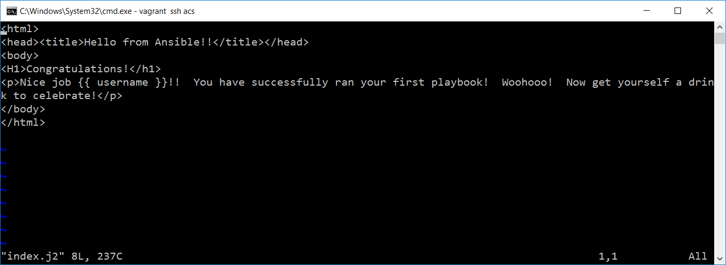

1. Now run the below command under exercise_7.1 directory which has inventory file

**ansible-playbook webserver.yml**

1. You will get below ouput:

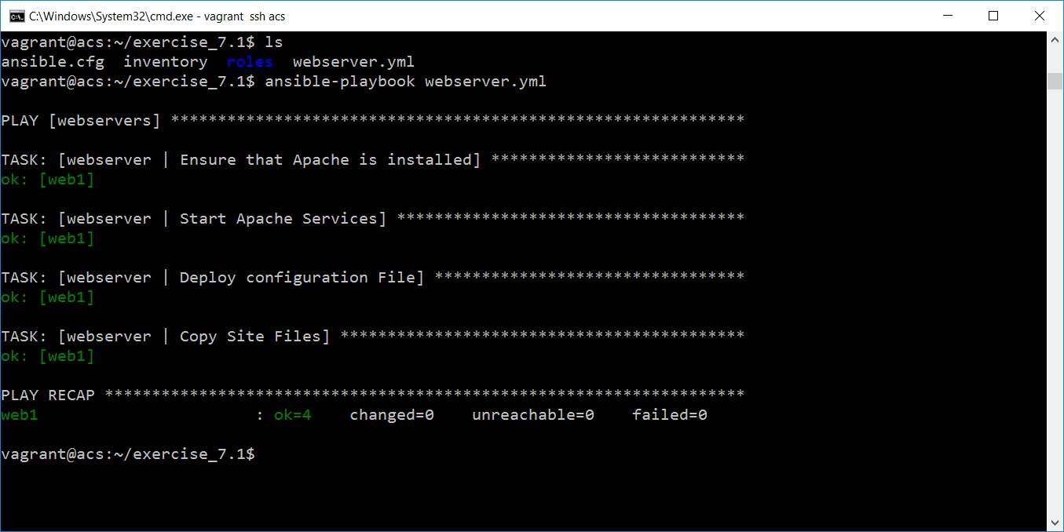

1. Now we are going to add dbserver roles

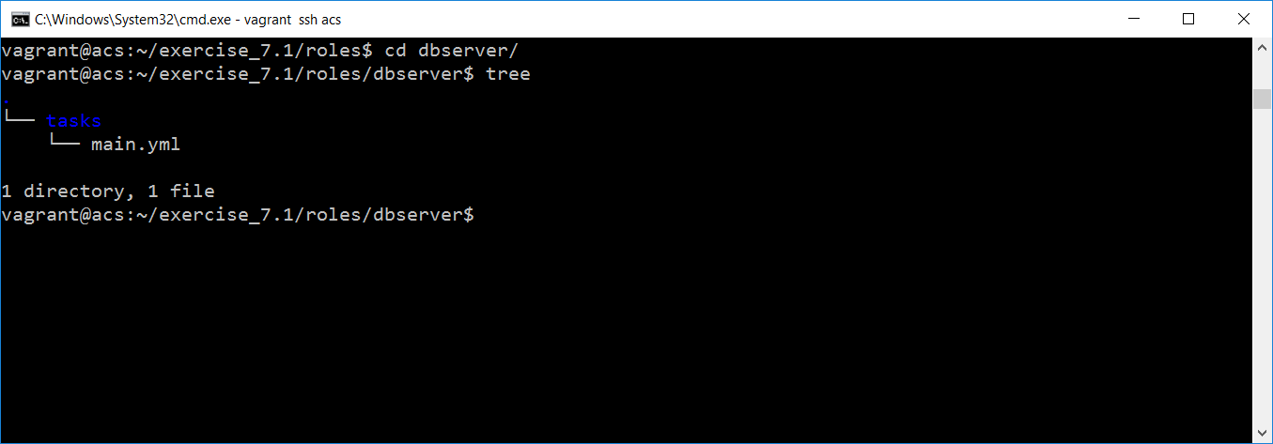

1. Create another directory called dbserver inside roles directory. Add following files and folders in this directory:
2. Addbelow code under roles/dbserver/tasks 🡪 main.yml file

**main.yml**

---

- name: Ensure MySQL is installed

yum: name=mysql-server state=present

- name: Start MySQL

service: name=mysqld state=started

1. Add dbserver.yml file under exercise_7.1 directory with following content within it.

**dbserver.yml**

---

- hosts: webservers

sudo: yes

roles:

- dbserver

gather_facts: no

1. Also modify your inventory file as mentioned below with **[datacenter: vars]**

**inventory**

acs ansible_ssh_host=192.168.33.10 ansible_ssh_user=vagrant ansible_ssh_pass=vagrant

web1 ansible_ssh_host=192.168.33.20 ansible_ssh_user=vagrant ansible_ssh_pass=vagrant username=ansible_user

db1 ansible_ssh_host=192.168.33.30

[webservers]

web1

[dbservers]

db1

[datacenter:children]

webservers

dbservers

[datacenter:vars]

ansible_ssh_user=vagarnt

ansible_ssh_pass=vagrant

1. Now run the below command

**ansible-playbook dbserver.yml**

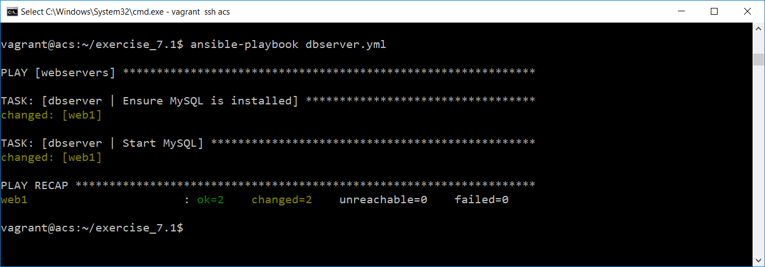

troubleShoot:

If your get below error wile you run dbserver.yml

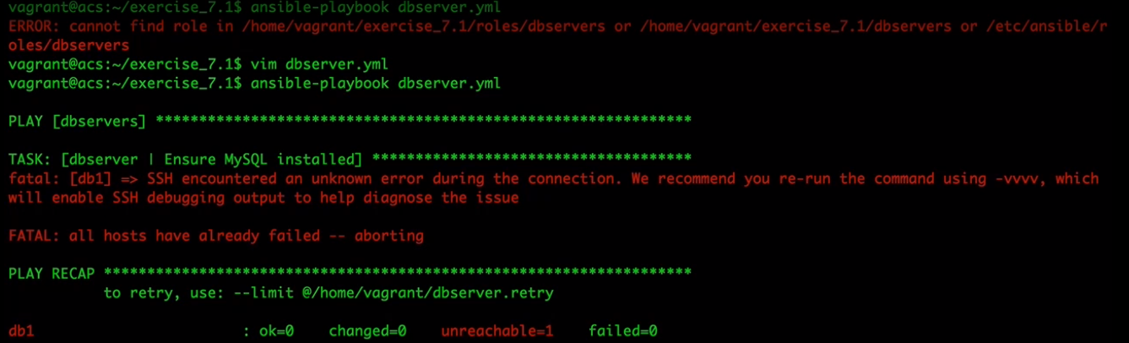

Enter below command to login to db server. And exit from there. And then continue with acs server.

**ssh vagrant@192.168.33.30**

Server Common Configurations in Roles

1. Create one more directory under roles called server-common

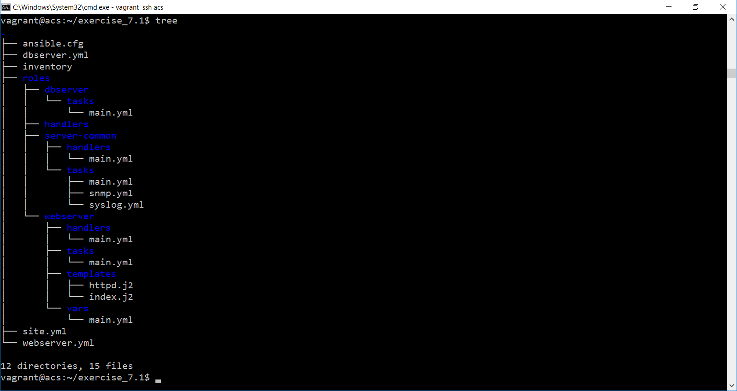

1. Add the files and folders as per the above structure. Look at below main.yml under tasks.

**main.yml**

---

- include: snmp.yml

- include: syslog.yml

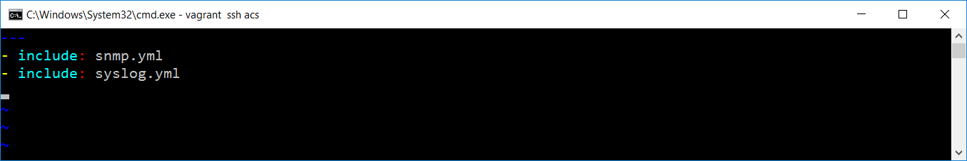

1. Look at below snmp.yml file under tasks.

**snmp.yml**

---

- name: Install net-snmp

yum: name=net-snmp state=present

- name: Install snmp utils

yum: name=net-snmp-utils state=present

- name: Deploy SNMP Config

template: src=snmpd.conf.j2 dest=/etc/snmp/snmpd.conf

notify: SNMP Restart

- name: Make sure service is running

service: name=snmpd state=started

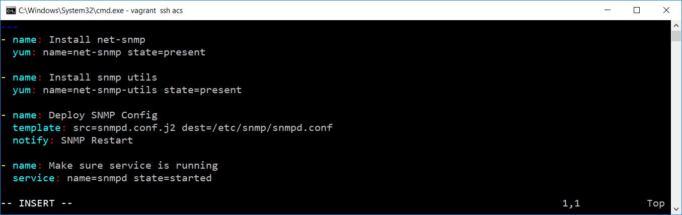

1. Add the syslog.yml file under tasks:

**syslog.yml**

---

- name: Install rsyslog

yum: name=rsyslog state=present

- name: Deploy syslog config

template: src=rsyslog.conf.j2 dest=/etc/rsyslog.conf

notify: Syslog Restart

- name: Verify Syslog Running

service: name=rsyslog state=started

1. Add below main.yml file under handlers

**main.yml**

---

- name: SNMP Restart

service: name=snmpd state=restarted

- name: Syslog Restart

service: name=rsyslog state=restarted

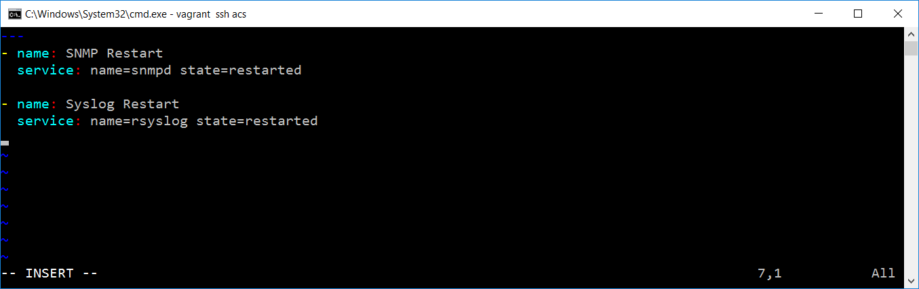

1. Add site.yml file under exercise_7.1 directory.

**site.yml**

---

- hosts: webservers:dbservers

sudo: yes

gather_facts: no

roles:

- server-common

- include: webserver.yml

- include: dbserver.yml

1. Now run the below command you will get below output.

**ansible-playbook site.yml**

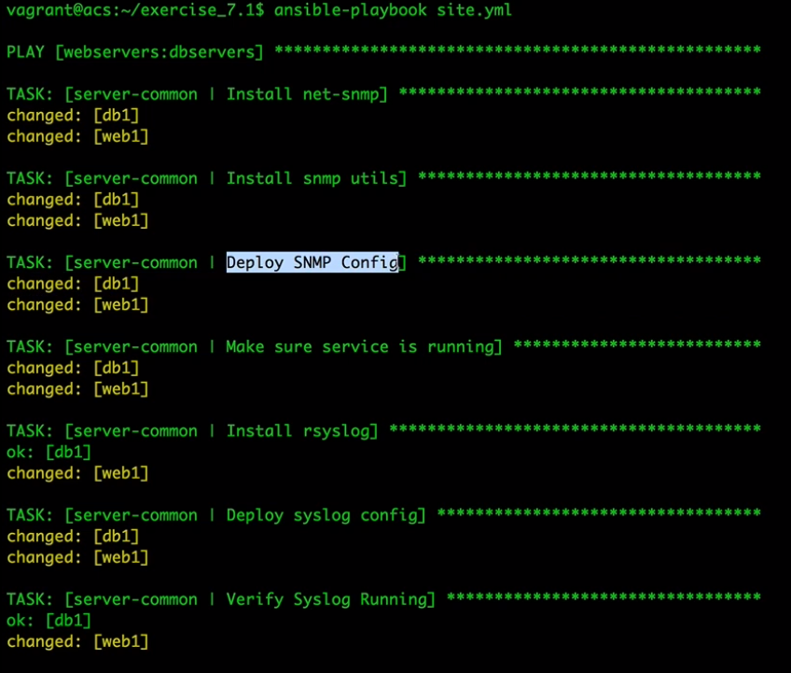

**Ansible Galaxy:**

1. Open your browser and enter below URL

**galaxy.ansible.com**

1. Click browse roles
2. You can see below screen:

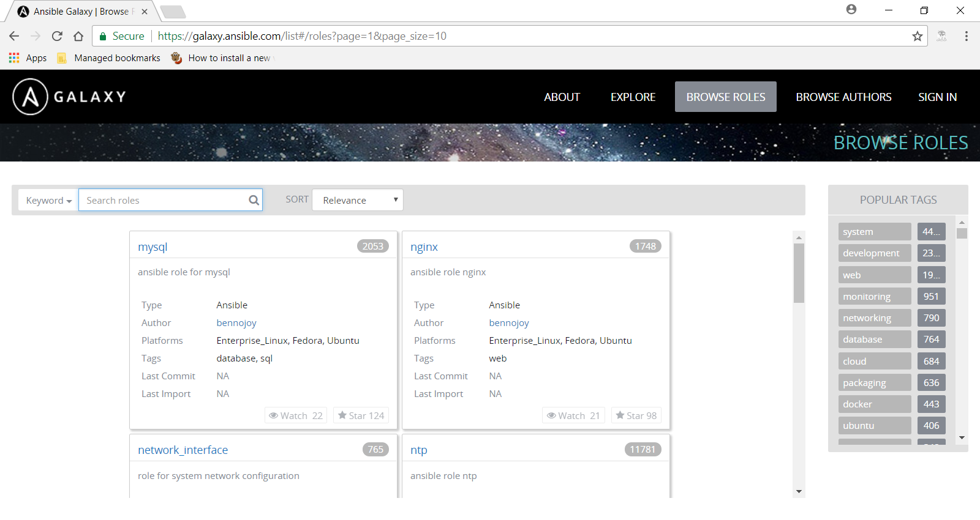

1. IN the search window select platform🡪ubuntu and keyword 🡪git

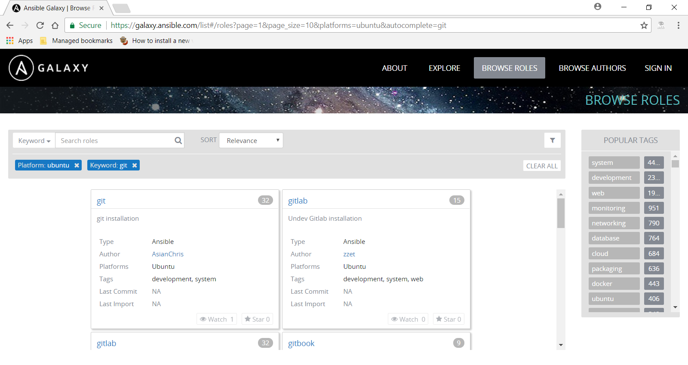

1. And then clear all.
2. Search platform🡪el and keyword 🡪 git, sort with downloads you will get below option

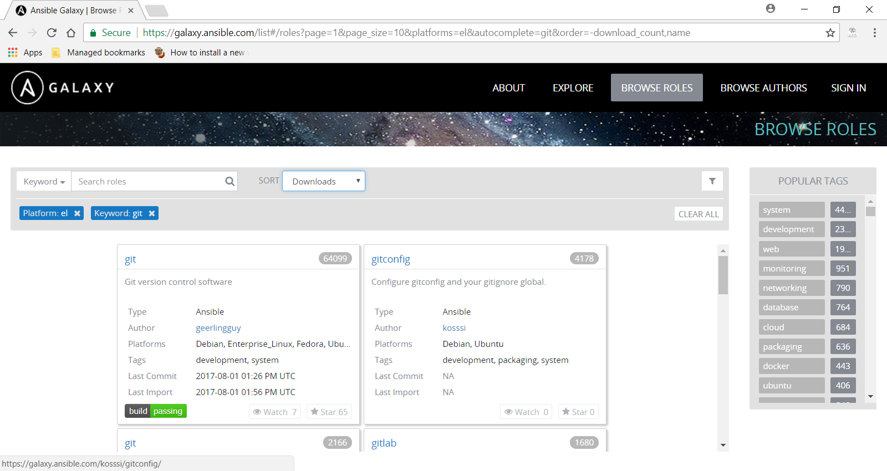

1. Click on git, you will get below command

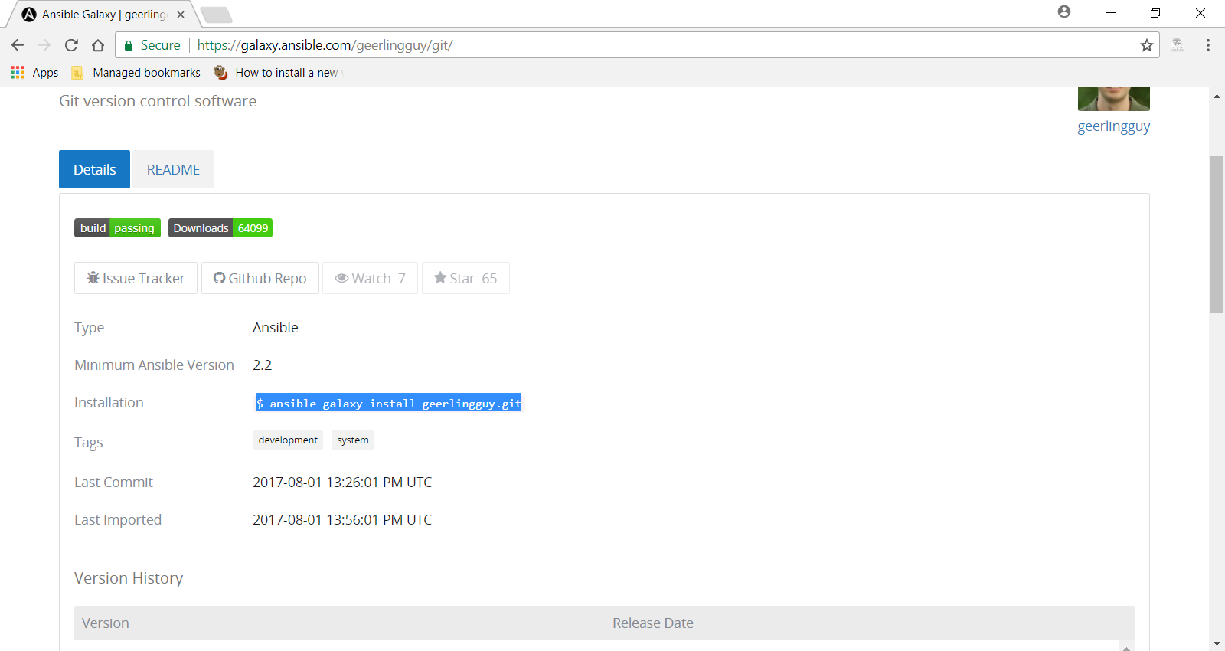

1. Use the below command to download user roles in acs server

$ ansible-galaxy install geerlingguy.git

1. Open acs server

vagrant ssh acs

1. Create new directory called exercise_7.2. and enter below command

sudo ansible-galaxy install geerlingguy.git

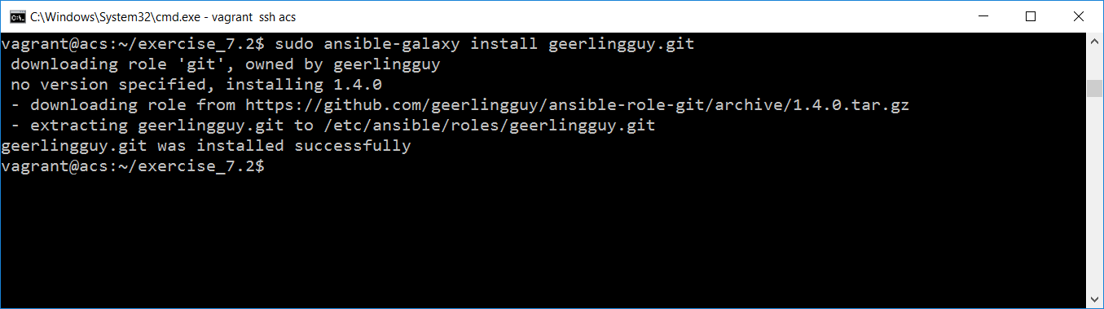

1. Enter below command to check the directory structure

ls /etc/ansible/roles/geerlingguy.git

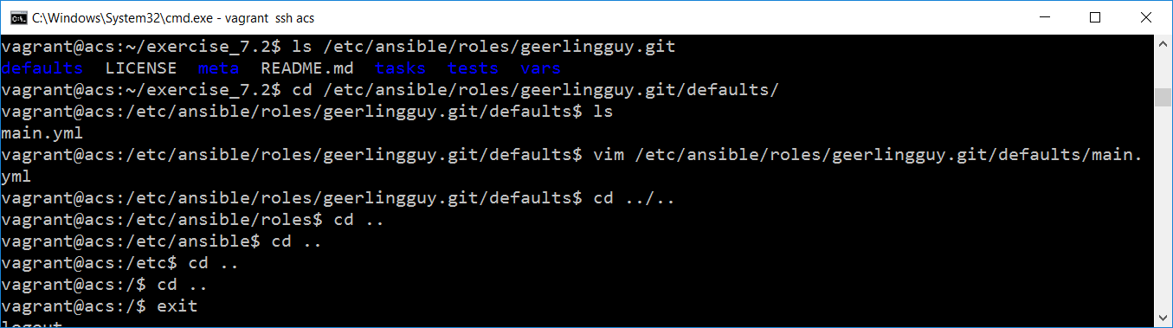

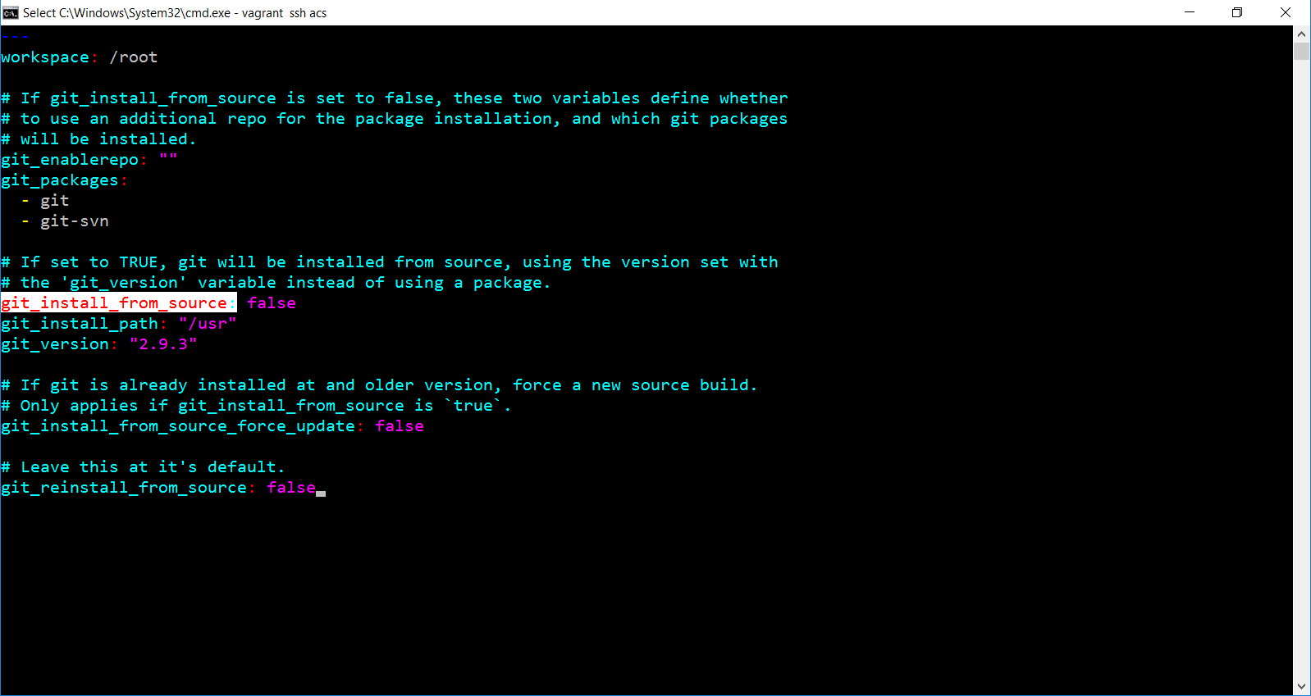

1. Add git.yml file under exercise_7.2 directory

**git.yml**

---

- hosts: webservers

sudo: yes

roles:

- geerlingguy.git

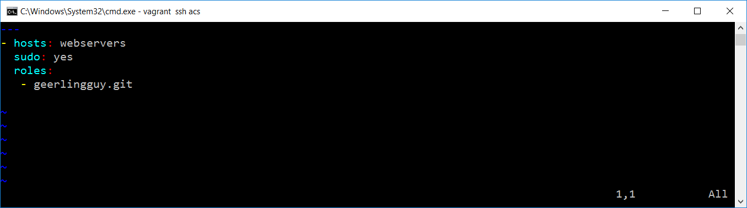

1. Add inventory file as well:

**inventory**

acs ansible_ssh_host=192.168.33.10 ansible_ssh_user=vagrant ansible_ssh_pass=vagrant

web1 ansible_ssh_host=192.168.33.20 ansible_ssh_user=vagrant ansible_ssh_pass=vagrant username=ansible_user

db1 ansible_ssh_host=192.168.33.30

[webservers]

web1

[dbservers]

db1

[datacenter:children]

webservers

dbservers

[datacenter:vars]

ansible_ssh_user=vagrant

ansible_ssh_pass=vagrant

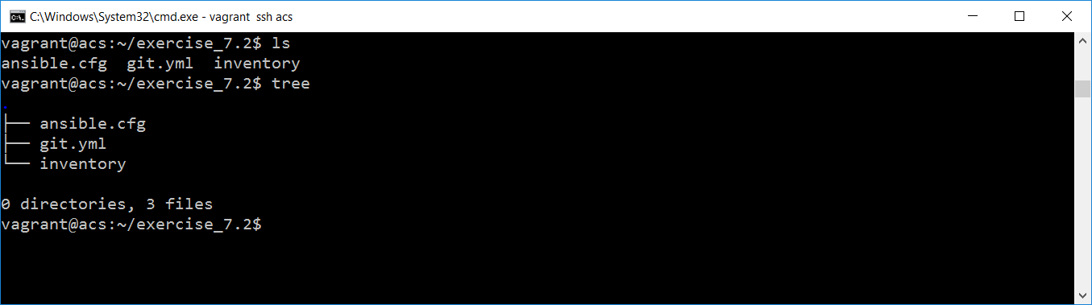

1. Add ansible.cfg file under exercise_7.2 directory

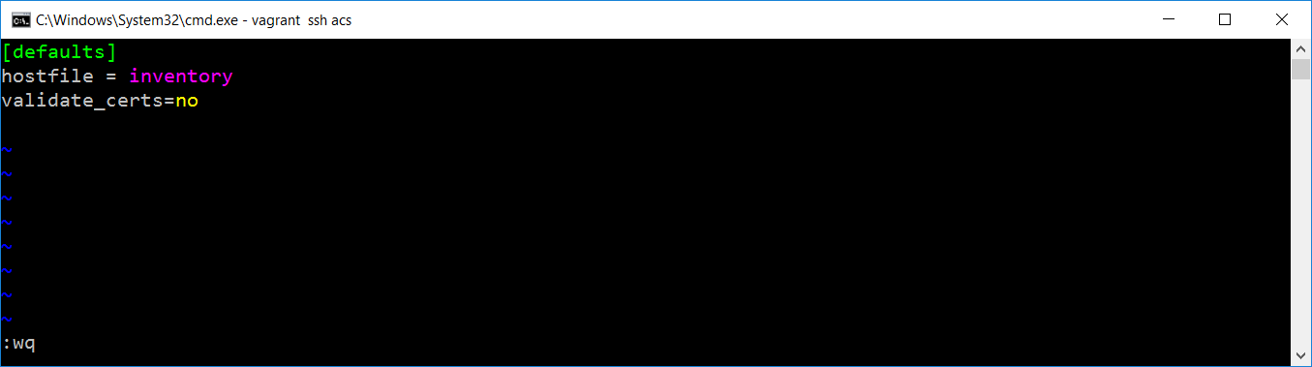

1. Now run the below command

ansible-playbook git.yml

1. You will get below output: